Behaviour of Al6061-T6 alloy at different temperatures and strain-rates: experimental characterization and material modelling

M. Scapin^{a,1} A. Manes²

¹ Politecnico di Torino, Department of Mechanical and Aerospace Engineering, Corso Duca degli Abruzzi, 24 – 10129 Turin, Italy
² Politecnico di Milano, Dipartimento di Meccanica, Via La Masa 1, 20156 Milan, Italy

Abstract. The simulation of impact scenario against a structure requires the use of material models able to reproduce all aspects of the mechanical behaviour of the involved materials; plastic flow is one of the main aspects to be reproduced. In more detail, attention has to be paid to the investigation of strain-rate and temperature sensitivities, as well as their interaction, which necessitates the use of a reverse engineering approach. The present paper mainly focuses on the tensile behaviour and an ad-hoc testing campaign was performed on cylindrical dog-bone specimens made in Al6061T6 at different temperatures and strain-rates extending the range up to a level where, at present, there is a lack in the scientific literature. The thermal softening effect was investigated in quasi-static as well as in dynamic loading conditions from room temperature up to 400 °C; while the material strength dependence on the strain-rate was studied up to 10⁴ s⁻¹ on miniaturized samples. Microstructure analyses were performed to better investigate the mechanical response at different loading conditions. The parameters of the Johnson-Cook model were identified starting from experimental data via a numerical inverse approach based on FEM simulations. These parameters can be used for simulations of extreme loading scenario like ballistic impact events.

Keywords: Al6061 T6; Hopkinson Tension Bar; Strain-rate; thermal softening; Johnson-Cook model; reverse engineering approach; microstructure analysis; ballistic impact;

1. Introduction

Extreme loading conditions like ballistic impacts, explosions and several technological processes subject the material involved to a very high strain-rate combined with high levels of deformation, temperature and damage. These loading conditions represent a challenge in the design and assessment of critical mechanical components and/or manufacturing process. Although experimental testing is fundamental for a reliable approach, alternative methods such as numerical simulations are now an actual and valid option. Obviously, the reliability of the Finite Element models results strongly depends on the capability of the material model to correctly reproduce the material behaviour under these extreme conditions. In such complex scenarios, different aspects have therefore to be considered: the generation and propagation of elastic and plastic waves, the contribution of deviatoric and hydrodynamic deformation, the thermo-mechanical coupling effects, crack propagation and the failure condition. In addiction the deformation process is adiabatic: the heat generated from the conversion of the plastic work has no time to disperse and the consequent relevant rise in temperature has to be considered.
A comprehensive constitutive model should consider all these effects. A common approach is the superposition of sub-models each of them able to describe a part of the above-mentioned aspects, while neglecting coupled effects between each contribution. The plastic flow and the effects of plastic strain, strain-rate and temperature, as well as their mutual influences are described with a strength model. The material damaging and the material fracture are predicted by defining an appropriate failure model whereas the hydrodynamic stress is related to other thermodynamic quantities by the definition of a proper equation of state. Such a simplified approach is supported by some experimental evidence and results in obtaining the material characterization by performing a limited number of relatively simple tests.
In the present work, the attention was focused on the plastic flow description and the definition of appropriate strength models for Al6061-T6 alloy to predict its behaviour under extreme conditions, in terms of strain-rate and temperature dependencies. In order to achieve this aim, various parameters had to be addressed including the choice of the most suitable strength material model, the strategy to calibrate its parameters and the account for the strong coupling between the strain-rate and the temperature, which results at high level of plastic strain due to the short time scale of the phenomenon. Correlation and validation between experimental results and microstructure evolution were achieved by means of microstructural analyses of the fracture surface performed for several loading conditions.
The Johnson-Cook material model was chosen and calibrated in this work (by means of reverse engineering approach), since it takes into account the effect of strain hardening, strain-rate and temperature dependencies in a simple but effective way; moreover, this model is suitable to describe a large variety of metal materials with different crystal structures and, therefore, it is widely included in several numerical solvers. A brief discussion of the defining factors leading to this choice is reported below.
A reverse engineering approach was used for the determination of the material model parameters to account for the coupling between strain-rate and temperature and to extend the range of strain up to fracture in post-necking regime. This coupling is typical in case of ballistic impact, in which the adiabatic condition is often reached in a very localized portion of the involved components, where the strain-rate is maximum. Hence, temperature and strain-rate act in opposition causing the resultant behaviour of the materials: the strain-rate increments the material strength and its plastic hardening capability which in turn increases the temperature and generates a softening effect. In the early phase of the impact, which is characterized by a low level of plastic deformation and a high strain-rate, an increase in strength is the main effect; however, in the next phase, where the increase of plastic deformation and the reduction of the strain-rate by energy dissipation occur, the temperature is a highly contributing factor.

2. Literature review
The 6000-series aluminium alloy is extensively used in the transportation and energy industry. Its properties, including a favourable weight-resistance ratio, the resistance to corrosion, a good weldability as well as machinability in conjunction with toughness, makes this series very attractive for lightweight design especially aimed to frame (plane, car, bike, etc).
Specifically, the Al6061T6 alloy is a tempered grade T6, which means that it has been solutionized and artificially aged. This alloy is a very versatile material also used in laminate plate material for high velocity impact [1]. Its favourable mechanical properties make it presently an extensively studied alloy especially in the field of optimization of manufacturing processes [2-5]. However, all of the applications of the Al6061T6, involve the use of the material in processes which are influenced by phenomenon like strain hardening, strain-rate and temperature and therefore an improvement of the calibration of the constitutive model for this material is of prime interest.
A very recent paper [6] investigated the compressive strength of the Al6061T6 as a function of high strain-rate. The preliminary discussion of that paper highlighted many ambiguities in the literature regarding the effects of temperature and strain-rate on the compressive strength. The dynamic compressive strength was investigated by means of SHPB while a SEM investigation showed a strong change in the microstructure modification at a strain-rate varying from 4148 s⁻¹ to 6519 s⁻¹. Strain-rate sensitivity was apparently enhanced in the passage from 5475 - 6181 s⁻¹ to 6181-6519 s⁻¹. However thermal activation volume seemed to decrease in this variation of strain-rate range.
Previous work [7] did not show any significant increase in strength at high strain-rates (>10,000 s⁻¹) and the constants presented in that paper have been used extensively over the years to represent the ballistic response of Al6061T6 with good results [8]. Nevertheless, another work [9] showed a significant deviation between the J-C model prevision, obtained by using the material parameter in [7], and the experimental results. In [9] an increase in strength above a strain-rate of 10³ s⁻¹ was shown and justified by the authors due to a change in the deformation mechanism.
In [10], the authors reported the trend of the maximum stress obtained by a SHPB tensile and compressive tests and highlighted a dynamic behaviour with an increase in strength of Al6061T6 starting from a strain-rate of about 10³ s⁻¹. Also in [11], a step increase in the flow stress of Al6061T6 was observed, but differently from the results reported in other papers, it was observed to start from about 10⁴ s⁻¹. In [12], the effects of a temperature up to 350°C and a strain-rate up to 5×10³ s⁻¹ was investigated also focusing on the microstructural evolution using a compressive SHPB system. Also in this case, an increase in the flow stress at about 10³ s⁻¹ was acquired and was justified with a greater rate of dislocation generation and multiplication (by TEM observation). The combined effect of strain-rate and temperature has been investigated in [13] for a generic alloy 6061. The authors made tests up to 10⁴ s⁻¹ and at a temperature up to 673 K. They also calibrated a Johnson-Cook (JC) model but without the interaction between the different parameters and without the use of numerical models (like in the present papers). According to the results presented in [13] the calibrated JC model partially failed to describe the behaviour of the material at high temperature whereas for strain-rate effect, good results were obtained for low strain-rate (where the strain-rate sensitivity is very low) but a comparison at high strain-rate was not performed. In contrast to other papers strain-rate sensitivity seemed very low. It is worth to mention that the material seemed to be not in a tempered grade T6 like the material analysed in the present paper. However, the results of the paper underline the need for further investigations with the use of numerical models in order to calibrate the JC parameters by means of a reverse engineering approaches where strain-rate and temperature effect are fully considered. The effect of the strain-rate on fracture morphology was reported also in [14] where fractography showed that ductile failure mode was dominant for such an alloy and that the strain-rate produced rougher fractures and more particle cracking. However, in that paper only intermediate strain-rate were investigated on Al6061T6.
Previously, the authors of the present paper performed an investigation on the mechanical properties of Al 6061T6 [15] with a relevant application in the field of impact engineering [16-17-18] and the results were compared with results from the scientific literature [9]. These past works underlined the importance of a correct material calibration in predicting the effect of a ballistic impact, as well as the need of a more in-depth investigation in the strain-rate range close to 10⁻⁴ s⁻¹ to better highlight the piecewise behaviour of the flow stress. Moreover, also the temperature sensitivities need to be further investigated to be able to correctly consider the coupled effect due to the adiabatic heating. In addition, in [15] the material modelling approach for Al6061T6 was discussed and it was concluded, also in accordance with the results reported in the scientific literature, that the Johnson-Cook model is a good choice in terms of balance between simplicity and capability to predict the material response in case of impact.
Therefore, from the above discussion of the relevant literature data, it is evident that there is still a need for a further investigation regarding the high rate deformation of Al-6061 especially close to the range of 10⁴ s⁻¹, as well as the high temperature behaviour under tensile loads.
These are the main aims of this paper, in which a testing campaign, performed in tension, by varying the temperature and the strain-rate, was performed on Al6061-T6 dog-bone specimens. The obtained experimental results were used in a hybrid analytical-numerical procedure for the identification of the material model parameters for the Johnson-Cook model. Results were also be discussed by means of microstructure observations of the fracture surfaces.

3. Material and experimental testing campaign
The composition of the material under investigation, Al6061-T6, is reported in Table 1. The chemical composition additionally analysed by means of an X-ray EDS (Energy Dispersive Spectroscopy) system, is also reported.
The investigated range in the strain-rate started from a quasi-static condition and was extended up to 10⁴ s⁻¹ to reach a strain-rate closer to the ones developed during a ballistic impact phenomenon. In addition, to evaluate thermal softening and the coupling between strain-rate and temperature, tests at various temperatures were performed both in quasi-static and in dynamic regimes up to 400 °C. The experimental data analysis was performed in two steps: first, an analytical approach was followed by considering a limited range in strain (in order not to reach the necking condition); then a reverse engineering approach based on FE simulations was applied.

Table 1. Al6061-T6 chemical composition.
 | Al % | Mg % | Si % | Fe % | Cu % | Mn % | Cr % | Zn % | Ti %
Nominal | 98 | 0.2 - 1.2 | 0.4 - 0.8 | 0.7 | 0.15 – 0.4 | 0.15 | 0.04 – 0.35 | 0.25 | 0.15
Measured | 94 -97 | 1.05 -1.45 | 0.5 -1.06 | 1.2 | 0.46- 0.63 | 0.11 | 0.02 | - | 0.04

Fig. 1, shows an image of the specimens with specified dimensions. For the tests, up to a nominal strain-rate of 10³ s⁻¹ (at different temperatures) the geometry S1 was used with a gage length of 5 mm and a gage diameter of 3 mm. For tests at a very high strain-rate (10⁴ s⁻¹) the miniaturized specimen S2 was adopted which presents a gage length of 1.5 mm and a gage diameter of 1.5 mm. Additional quasi-static tests at room temperature were performed on this second geometry in order to compare the results. For each loading condition, at least 3 valid tests were performed in order to check the material scatter.

a) b)
Fig. 1. Specimen geometry used in the testing campaign: geometry S1 for tests at different temperatures up to 10³ s⁻¹ (a); geometry S2 for very high strain-rate tests (10⁴ s⁻¹) and quasi-static tests at room temperature for comparison (b).

The investigated strain-rate range varies between 10⁻³ and 10⁴ s⁻¹. The tests at low and medium strain-rate were carried out on standard electro-mechanical and servo-hydraulics testing machines, respectively. The high strain-rate tests were performed by using a Hopkinson bar setup [19]. For the tests nominally at 10³ s⁻¹ of strain-rate, a standard setup in the direct configuration was adopted [20]. For the tests nominally at 10⁴ s⁻¹ of strain-rate, an ad-hoc setup was used, which consists of a miniaturized setup developed for specimen S2, in which the diameter of the output bar was reduced accordingly with the specimen dimension. This setup allowed to reach higher strain-rates than those achievable with the standard setup, since the input bar velocity was about 25 m/s (reached in 10 μs) [21]. This setup was coupled and synchronized with a high-speed camera (Photron SA5) and a pulsed light system for the measurements of kinematic quantities, especially for the input side: the high acceleration imposed to the system does not permit the use of any wired measuring system, such as strain-gages. Otherwise, on the output side the force and displacement measurements were performed by using semiconductor strain-gages.
The investigated temperature range varies between room temperature and 400 °C. For the specimen heating an induction system was developed to concentrate the heat flux in the gage section of the specimens. The temperature was controlled on the measurements performed by thermocouples welded on the experimental setup due the problems associated with welding onto aluminium alloy: a preliminary calibration was performed to correlate the measured temperature with that of the gage section. The same system was used both for the quasi-static and dynamic tests.

3.1 Results
Engineering stress-strain curves are reported in the diagrams of Fig. 2. The onset of instability and the consequent presence of necking, which in general takes a considerable part of the entire tests, do not permit showing the results in terms of true stress-strain curves, since their relationships are no longer valid when triaxial state of stress is developed. Moreover, they imply the use of an FE approach to get equivalent stress-strain curves which allow the comparison of the results up to fracture (see the section below). The data were obtained from force-displacement curves exploiting nominal gage length and the cross-section area. The evaluation of the gage length deformation was based on the stroke measurement performed by using a digital elaboration technique on the gage length (e.g. optical extensometer). The temperature dependence of the Young’s Modulus was in accordance with the results shown in [22], where the thermal effect on the Young’s Modulus did not affect the final results when the attention was focused on the plastic behaviour of the material up to fracture (e.g. for high level of strain). Only one curve for each testing condition is shown, which is the closest one to the average curve: the average curve was not used to keep the link with a specific specimen for the final comparison between computed and experimental results (e.g. shape of necking region). An indication of the data scatter can be derived from the results reported in Table 2. For each loading condition average (indicated with “av”) and standard deviation (indicated with “std”) values of yield and ultimate stresses are reported. For high strain-rate tests, the evaluation of the yield stress is difficult, since the curves can present peaks and oscillations which are not related to the material behaviour, but they come from inertia and/or initial misalignments of the system. For this reason, a precise evaluation of the yield stress was not possible and only the average value was reported in the Table 2. Also the cross-section reduction was reported. As it is possible to notice, the scatter of the quasi-static results was very limited up to 250 °C, while it increased for higher temperatures. By increasing the strain-rates, the data scatter was higher in all the investigated temperatures above room temperature. The cross-section reduction was also measured for some specimens based on SEM images reported in Figure 4. These results agree with the different behaviour of the specimens, as far as ductility is concerned, shown in Figure 2.

Table 2: Average and standard deviation values for yield and ultimate stresses for all the testing conditions
 | TR | 100 °C | 200 °C | 250 °C | 300 °C | 400 °C
Quasi-static (S1 specimen)
σ_{y,av}±std (MPa) | 299±3 | 276±2 | 229±5 | 193±3 | 105±7 | 25±10
σ_{u,av}±std (MPa) | 325±2 | 305±1 | 238±1 | 200±3 | 108±6 | 27±8
Cross section area reduction (%) | 37 (Fig. 4a) | - | 29 (Fig. 4b) | - | 19 (Fig 4c) | -
Medium strain-rate (S1 specimen)
σ_{y,av}±std (MPa) | 304±3 | - | - | - | - | -
σ_{u,av}±std (MPa) | 341±2 | - | - | - | - | -
High strain-rate (S1 specimen)
σ_{y,av}±std (MPa) | 320 | 303 | 273 | 167 | 105 | -
σ_{u,av}±std (MPa) | 348±3 | 325±10 | 285±7 | 199±20 | 151±5 | -
Cross section area reduction (%) | 14 (Fig. 4d) | - | 23 (Fig. 4e) | - | 69 (Fig 4f) | -
Very high strain-rate (S2 specimen)
σ_{y,av}±std (MPa) | 340 | - | - | - | - | -
σ_{u,av}±std (MPa) | 360±20 | - | - | - | - | -
Cross section area reduction (%) | 58 (Fig 4h) | - | - | - | - | -

The material response at room temperature and different strain-rates is reported in Fig. 2.a for tests up to 10³ s⁻¹. As expected from the results reported in the scientific literature, up to a medium level of strain-rate the material was more or less insensitive to strain-rate and the increment in the material strength is low. A further increase in the strain-rate produced a considerable increment in the materials strength. The experimental data showed the mechanical responses were coherent in the uniform elongation phase, while a more scattered behaviour was obtained after necking. The results obtained for very high strain-rate are reported in Fig. 2.b and compared with the quasi-static result obtained on the same geometry. The difference in the specimen dimension of the two geometries prevented a direct comparison of the engineering results since they are strongly influenced by the geometry. The comparison could however be achieved by implementing FE models of the two geometries and comparing equivalent stress-strain curves [21, 23]. The comparison of the results of Fig. 2.a and 2.b in the pre-necking phase demonstrated a significant increase in the mechanical response of the material by passing from 10³ to 10⁴ s⁻¹ of strain-rate. Fig. 3 shows some images of the necking phase extracted from high-speed videos for tests at room temperature at 10³ and 10⁴ s⁻¹ of strain-rate. Image analysis revealed that the necking induced in the S2 geometry was more pronounced than in the S1 one (as also underlined in table 2 as far as cross section area is concerned), which otherwise showed a more irregular deformation of the gage length.
The engineering curves obtained by varying the temperature in quasi-static regime are shown in Fig. 2.c, while in Fig. 2.d the results obtained at 10³ s⁻¹ of strain-rate are summarized.
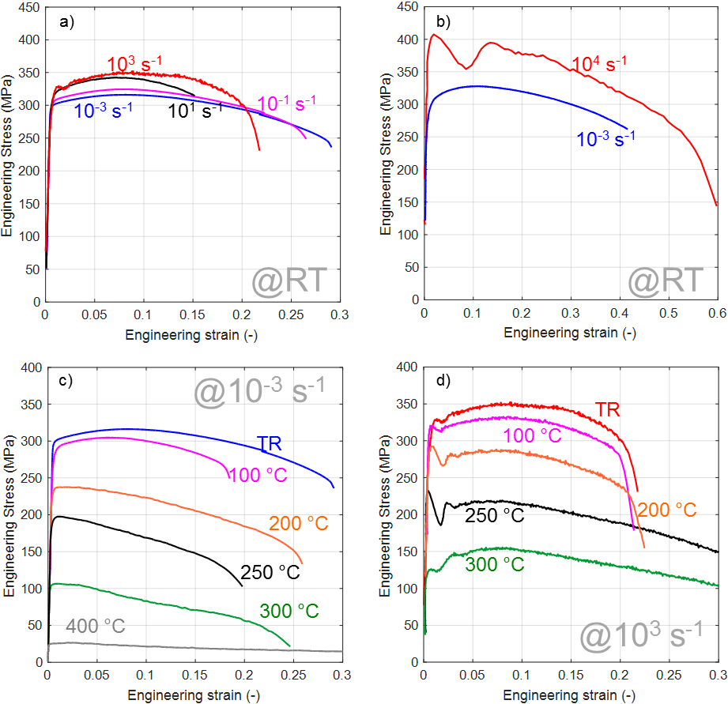
Fig. 2. Experimental results in terms of engineering stress-strain: a) at different strain-rates and at room temperature for specimen S1; b) at different strain-rates and at room temperature for specimen S2; c) at different temperatures and at a quasi-static strain-rate for specimen S1; d) at different temperatures and at high strain-rate for specimen S1.

In the quasi-static regime, the material exhibited an early instability starting from 200 °C, which produced a decrement of the mechanical response just at the end of the elastic phase. On the contrary, at 100 °C the material behaviour was still characterized by the presence of a hardening phase before necking. In the dynamic regime, the change in shape at the onset of necking was not observed, since the material response at each temperature was always characterized by a first phase of hardening followed by necking.
a) b)
Fig. 3. High speed camera images during the necking phase and at fracture for 10³ (a) and 10⁴ (b) s⁻¹ tests: the test at 10³ s⁻¹ was recorded at 50000 f/s with a resolution of 640×224 px; the test at 10⁴ s⁻¹ was recorded at 262500 f/s with a resolution of 384×56 px.

3.2 Microstructure observation
In this section, the microstructure of the fracture surface of selected tested specimens at different loading conditions was studied by means of Scanning Electron Microscopy (SEM) fractography. The selected specimens correspond to the nominal testing conditions of Room Temperature (RT), 200°C and 300°C both in quasi-static condition and under strain-rate of 10³ and 10⁴ s⁻¹. This means that both the S1 and S2 specimens were analysed.
In Fig. 4, the images of the entire fracture surface (75× for S1 specimens and 150× for S2 specimens) are reported. Pictures 4.b (test at 200 °C and 10⁻³ s⁻¹), 4.c (test at 300 °C and 10⁻³ s⁻¹), 4.d (test at RT and 10³ s⁻¹) and 4.e (test at 200 °C and 10³ s⁻¹) show a more regular circular fracture surface. Specifically Figure 4.a (test at RT and 10⁻³ s⁻¹) shows a more pronounced shrink of the failure section with respect of the test carried out in quasi-static condition but at different temperatures reported in Fig. 4.b (test at 200 °C and 10⁻³ s⁻¹), Fig. 4.c (test at 300 °C and 10⁻³ s⁻¹). This behaviour is consistent with the curves reported in Fig. 2.c, where the specimen at RT showed a slight increase in strain at failure thus a larger ductility. On the contrary, in accordance with the results reported in Fig. 2.d a different behaviour is expected when high strain-rate is investigated: when specimens were tested at 10³ s⁻¹, strain increased strongly at failure for 300°C. This was clearly confirmed also by comparing figures 4.d (test at RT and 10³ s⁻¹) and 4.e (test at 200 °C and 10³ s⁻¹) with figure 4.f (test at 300 °C and 10³ s⁻¹). Specifically, the latter shows a remarkable shrinking of the failure surface.

Fig. 4. SEM images. S1 specimens at: a) RT and 10⁻³ s⁻¹, magnification 75×; b) 200 °C and 10⁻³ s⁻¹, magnification 75×; c) 300 °C and 10⁻³ s⁻¹, magnification 75×; d) RT and 10³ s⁻¹, magnification 75×; e) 200 °C and 10³ s⁻¹, magnification 75×; f) 300°C and 10³ s⁻¹, magnification 75×; S2 specimens at: g) RT and 10⁻³ s⁻¹, magnification 150×; h) RT and 10⁴ s⁻¹, magnification 150×.
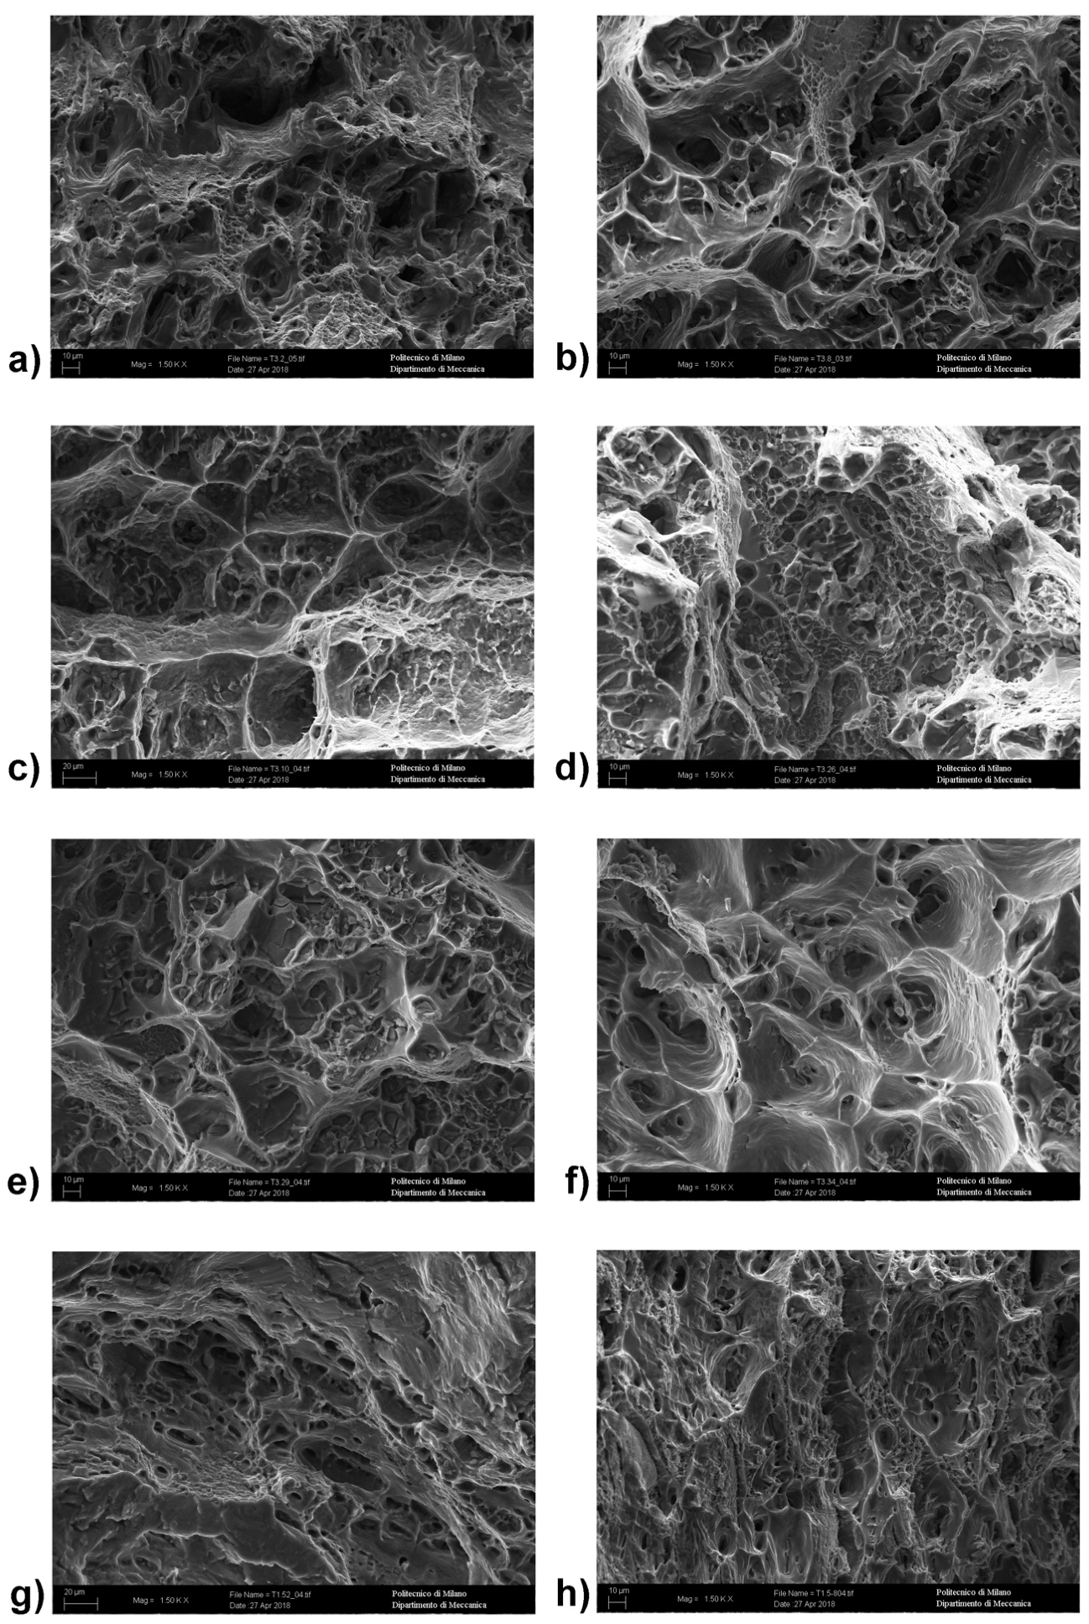
Fig. 5. SEM images magnification 1500x. S1 specimens at: a) RT and 10⁻³ s⁻¹; b) 200 °C and 10⁻³ s⁻¹; c) 300 °C and 10⁻³ s⁻¹; d) RT and 10³ s⁻¹; e) 200 °C and 10³ s⁻¹; f) 300°C and 10³ s⁻¹; S2 specimens at: g) RT and 10⁻³ s⁻¹; h) RT and 10⁴ s⁻¹. Some features (however the selection is not comprehensive) are been highlighted in green (voids and microvoids) and red (dimples)

In Fig. 5, the SEM images, at a magnification of 1500×, are reported for the same loading conditions. Coalesced voids, microvoids and dimples were present in all the images: this confirms the ductile behaviour expected for Al6061-T6 [24]. In quasi-static and RT condition, as reported in Fig. 5.a, macroscopic voids intermingled with finer microscopic voids were present. A slightly more regular pattern was visible by increasing the temperature in quasi-static condition, as in Fig. 5.b (test at 200 °C and 10⁻³ s⁻¹) and 5.c (test at 300 °C and 10⁻³ s⁻¹). However, size of the dimples did not change considerably with temperature.
By increasing the strain-rate, the size of dimples was reduced: the difference is clearly visible by comparing Fig. 5.d (test at RT and 10³ s⁻¹) with Fig. 5.a (test at RT and 10⁻³ s⁻¹). Even at a high strain-rate, the SEM analyses confirmed the ductility trend expected from experimental stress-strain curves, for which in high dynamic loading condition, by increasing the temperature, the strain at failure increased, especially for the 300°C. This behaviour was also evident in the cross sections that show an increasing percentage reduction moving from Figure 4d, 4e, 4f (see also table per percentage figures). This behaviour is also clear in Fig. 5.f (test at 300 °C and 10³ s⁻¹), which showed an increase in the size of the voids.
Finally, by moving to the small specimens S2, the quasi-static test (Fig. 4.g) was characterized by a fracture surface with a cup-cone shape with a propagation of the fracture surface that moved at 45° toward the periphery. This propagation behaviour was similar to the result obtained for specimen S1 in a similar condition (Fig. 4.a). Additionally, also the microstructure images of the two cases were very similar, as highlighted by the comparison between Fig. 5.g (test at RT and 10⁻³ s⁻¹ on S2) and Fig. 5.a (test at RT and 10⁻³ s⁻¹ on S1). Specimen tested at a very high strain-rate, e.g. RT and 10⁴ s⁻¹ (see Fig. 4.h and 5.h), showed a fracture surface with deformed dimples, that can explain the increase in ductility as registered in Fig. 2.b. For very high strain-rates also the cross-section percentage reduction was remarkable, see Figure 4h and Table 2. In any case, a final conclusion should be drawn by considering the effective plastic strain at failure, since the result could be strongly geometry dependent. This could be achieved by performing the FE analysis of the different loading conditions, once the strength material model is identified, and by comparing the effective plastic strain at the end of the test.
EBSD were also performed for the selected loading conditions, with a magnification of 1000×. In Fig. 6 one of them is reported, which corresponds to the quasi-static test at 200 °C. The analyses are reported in Table 1 and confirmed the nominal chemical composition, as also reported in Table 1. Moreover, an iron rich phases was found inside the voids as well as the presence of oxides at high temperatures.

Fig. 6. EBSD of specimen tested at 200°C and 10⁻³ s⁻¹, magnification 1000×.

4. Data analysis
A preliminary analysis of the results was performed by using a simplified approach to estimate the strain-rate and the thermal softening sensitivities for the Johnson-Cook model, by focusing the attention at low strain values, e.g. 5% which means before necking for the most part of the loading conditions. This value was chosen in order to overcome the oscillation at high strain-rate regimes. In this phase, a uniform elongation was expected and an equivalent stress-strain curve could be simply obtained from the engineering results. On the contrary, a reverse engineering approach is necessary when the analysis is extended to higher values of strain and during the necking phase (see section 4.1).
For the preliminary analysis all the repetitions of each experimental testing condition were considered, hence the experimental data scatter was considered.
With regards to the thermal softening evaluation, the true stress was calculated for a true plastic strain of 5% and reported in the diagram of Fig. 7.a, in which each datum was plotted at the initial testing temperature. The quasi-static and dynamic data were normalized by the corresponding average value at room temperature, in accordance with the J-C formulation. The comparison between quasi-static and high strain-rate results showed the thermal softening was quite insensitive to the strain-rate: the distance between the quasi-static and dynamic data for the tests at the same temperature was lower than the average experimental data scatter. This result justifies the use of the multiplicative model such as the J-C one.
The trend of the material strength as a function of temperature assumed the typical s-shape, with a sharp transition between 200 and 300 °C and a different behaviour for higher temperatures. For this reason, the quasi-static data at 400 °C was neglected, while all the other data were fitted with the J-C formulation. In the optimization process based on Mean Squared Error (MSE) both m and T_{m} (without any physical meanings) were considered as optimization variables. In this way, the parameter T_{m} was interpreted as the maximum temperature for which the material strength could not to be neglected. The prevision of the thermal softening model is reported in the diagram of Fig. 7.a as a solid line (m = 2.19 e T_{m} = 633 K) and reproduced the material response over the considered entire range of variation in temperature with a sufficient level of accuracy. With respect to the results reported in [15], the model prediction capacity was considerable improved, especially for temperatures above 200 °C: this is mainly due to the fact that the model in [15] was obtained without performing the tests at different temperatures, but the thermal effect was only derived from adiabatic heating of Hopkinson Bar tests.
Fig. 7. Preliminary evaluation of the thermal softening (a) and strain-rate (b) sensitivities in accordance with the J-C model (T model / S-R model).

A similar procedure was applied for the trial estimation of the strain-rate sensitivity. Also in this case, the true stress values were obtained in correspondence of a true plastic strain of 5% and then normalized with respect to the interpolated value at 1 s⁻¹ (in accordance with the original formulation of the J-C model). The data are reported in Fig. 7.b and each of them was assigned to the nominal strain-rate. This choice was related to the fact that the effective strain-rate could not be directly derived, since it depends on the effective portion of material which is deforming. Moreover, it is not constant during the entire test, since necking concentrated the deformation and of course also the strain-rate (and temperature, in adiabatic tests). In a Hopkinson Bar, in which usually a constant incident wave is used, the strain-rate profiles are derived from the difference between the incident wave and the transmitted force: hence also in the hardening phase the strain-rate is not constant and has the same profile of the force (e.g. engineering stress). For all these reasons, the effective strain-rate trend and distribution along the specimen could be indirectly obtained, once the material model was calibrated, by using the FE simulations in which the experimental boundary conditions were imposed (see section 5).
As anticipated, the strain-rate sensitivity was low up to 10³ s⁻¹, while it showed a significant increase starting from 10⁴ s⁻¹. The threshold was fixed to the nominal strain-rate of high strain-strain tests (e.g. 10³ s⁻1) and the data obtained with the Hopkinson Bar tests were fitted with a linear function in the semi-log plane. In accordance with the J-C formulation implemented in LS-DYNA [25], the strain-rate effects were completely neglected under the threshold at 10³ s⁻¹. The obtained model was reported as a dashed line and was used as a starting point in the reverse engineering approach based on the FE simulations described in the next section.

4.1 Reverse engineering approach
The reverse engineering approach was based on FE simulations of the experimental tests and the parameter identification was driven by the comparison between the experimental and computed quantities. The FE simulations considered non-uniform strain, temperature and strain-rate distributions inside the specimen caused by a triaxial state of stress induced by necking as well as the coupling effect between temperature and strain-rate in adiabatic loading conditions, which became more significant at high deformation.
The procedure was divided into two steps: the determination of the hardening parameters and the tuning of the strain-rate sensitivity, while the thermal softening coefficients were fixed to those obtained from the preliminary analysis. A more in-depth description of the procedure can be found in [23].
A numerical model for each test (in the quasi-static and dynamic regimes as well as on the two geometries) was modelled in LS-DYNA. The specimens were modelled via 2D axisymmetric elements and boundary conditions (e.g. displacement and constraints) were applied in order to reproduce the different loading conditions.
The optimization was performed using the software LS-OPT and the iterative procedure was based on the comparison between macroscopic quantities such as the force-displacement curves. The hardening parameters of the J-C model were identified based on the experimental data obtained from the quasi-static test at room temperature. The optimized parameters were: A = 225 MPa, B = 184 MPa and n = 0.157. The parameter A was not fixed a priori to the yield stress in this loading condition but was numerically optimized: this allowed the addition of one more optimization variable, which led to a better minimization of the difference between computed and experimental curves. The second step of the procedure was the implementation of a multi-case optimization on the dynamic tests (e.g. tests at 10³ and 10⁴ s⁻¹). The optimized material parameters were: C = 0.0396 and $\dot{ε_{0}}$ = 162 s⁻¹, which represented the strain-rate sensitivity threshold: below this value any effects of strain-rate were neglected. As previously discussed also for strain and temperature sensitivities, the choice to optimize also the threshold added a degree of freedom which provided better results in comparison to the choice to fix a priori the threshold to the nominal value of the high strain-rate test (as performed in the preliminary phase, see fig. 7.b). This came from the fact that the result of a Multi-Case Optimization process, like that reported in this paper, is a set of parameters which allowed to reach the best compromise among all the objective functions to be minimized.

5. Discussion
In relation to the field of application of the investigated material, which is the numerical simulation of impact events, the attention was focused on the understanding if the identified material model is suitable to reproduce dynamic loading conditions. Hence, the complete set of parameters was used to reproduce the dynamic results on both the geometries. Also the model predictions of the quasi-static cases are reported since they represent the reference condition. The comparison between the computed and the experimental force vs. the displacement curves is reported in Fig. 8. The model was clearly able to reproduce the different loading conditions with a good level of accuracy. A quite significant discrepancy was obtained for the test at 10³ s⁻¹ at high values of strain, caused by the particular irregularity of the necking phase. Both the estimated strain-rate sensitivity as well as the temperature dependence obtained from the Multi-case Optimization procedure were able to correctly predict the strength increment due to strain-rate and the thermal softening occurring in adiabatic loading condition and the high level of the effective plastic strain. With respect to the results reported in previous works, the main finding of the present paper is that a strength model was calibrated which can be applied for both high dynamic and high temperature applications up to fracture.
This set of parameters was also used in the numerical simulation of the quasi-static test on the geometry S2 (which was not taken into consideration for the parameter identification): the computed results were in accordance with the experimental ones. This demonstrated the portability of the model and the fact that the material behaviour was not expected to be influenced by the geometry. This result is in accordance with the result of the microstructure analysis, which revealed similar behaviour for the two geometries.

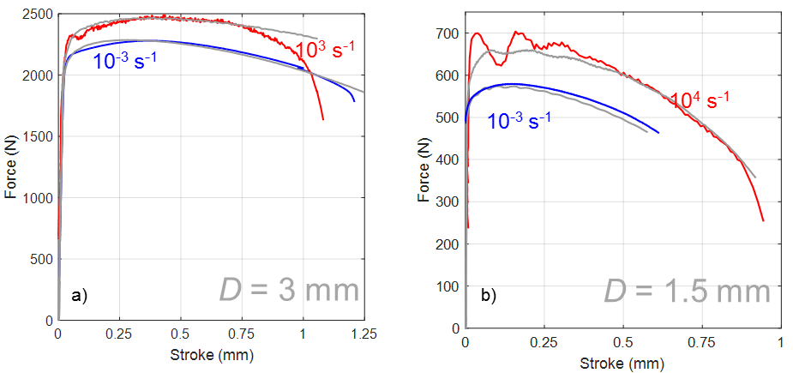
Fig. 8. Comparison between experimental and computed force vs. displacement curves for the quasi-static and dynamic tests performed on an S1 and S2 geometry.

Figure 7b and Table 3, that collect the optimized material model parameters for the Johnson-Cook model obtained in the present work, highlight that Al6061T6 was sensitive both to temperature and strain-rate. It is worth to mention that these parameters were obtained by a reverse engineering approach that allowed to take into account the mutual interaction of the temperature and the strain-rate in the hardening curves. Focusing on the strain-rate effect and especially on the parameter C, in [14] a range between 0.083 – 0.024 was identified while in [10] (the most cited paper as far Al6061T6 material parameters for J-C are concerned) a lower value of 0.002 was reported. In the present work a higher level of strain-rate was reached (greater than 10⁴ s⁻¹⁾ during the experimental tests. As in [7,9,12], also in the present work an increase in strength between 10³ and 10⁴ s-¹ was found and this behaviour had to be correctly considered in the calibration of the material model. Moreover, in the present work $\dot{ε_{0}}$ (the threshold value) was chosen as a parameter to be optimized. This allowed a better description of the strain-rate effect: a steady value for a low condition and a steeper variation for higher strain-rate conditions. The lower C value reported in [10] could still be used for a low strain-rate regime (as shown in figure 7b) but for the simulation of events with a higher strain-rate this new approach should provide better results due to its ability to describe the peculiar kink observed by the present authors and in [7,9,12] in the range between 10³ and 10⁴ s⁻¹.
A further evaluation of the capability of the model to correctly predict the material response was performed by comparing experimental and computed results in terms of the deformed shape in the necking region. The qualitative comparison is reported in Fig. 9 for the dynamic tests on the two geometries. The model correctly generated the experimental necking shape.
Since the validity of the model was demonstrated, the numerical results were used to investigate the actual distribution of strain, temperature and strain-rate inside the specimen. The prevision of the trend of the effective plastic strain at failure with a strain-rate obtained from the fracture analysis was confirmed. Different geometries but tested at the same strain-rate reached similar strain at failure. As a function of strain-rate, a reduction in ductility was found by passing from quasi-static to high strain-rate, while an increment was obtained at a very high strain-rate. The temperature and strain-rate distributions at a fixed time during necking are reported in Fig. 9. These maps allowed the evaluation of the temperature increment due to adiabatic self-heating, the localization of deformation induced by triaxiality and the consequent non-uniform distribution of the strain-rate, which increased substantially during the test in the deformed region. As anticipated, in the tests at 10⁴ s⁻¹ of strain-rate, a more pronounced necking was developed. This was also confirmed by the computed distribution, which was more uniform over the specimen gage length in the model reproducing the test at 10³ s⁻¹ of strain-rate. For the strain-rate distribution, the maximum (red) computed value was 3000 s⁻¹ on S1 and 50000 s⁻¹ for S2. For the temperature increment distribution, the maximum (red) computed value was 45 °C on S1 and 160 °C for S2.

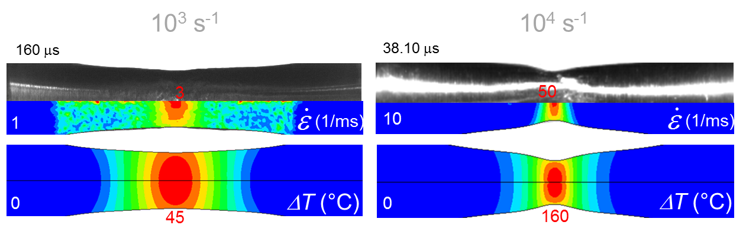
a) b)
Fig. 9. Qualitative comparison between the experimental and computed deformed shape for the dynamic tests performed on the S1 (a) and S2 (b) geometry; spatial distribution on the specimen of strain-rate and temperature (maximum values: red; minimum values: blue).

5. Conclusion
In the present work, a testing campaign was performed in tension by varying the temperature and the strain-rate on Al6061-T6. The obtained experimental results were used in a hybrid analytical-numerical procedure for the identification of the material model parameters for the Johnson-Cook model.
With respect to previous works, available in the scientific literature, the range of strain-rate was extended up to 10⁴ s⁻¹ and coupled testing conditions at high strain-rate and temperature (up to 400 °C) were investigated. This is a very consistent step because, as highlighted in the introduction, previous research showed a change in the material behaviour in between 10³ and 10⁴ s⁻¹ but with practically no test close to 10⁴ s⁻¹ thus extrapolating the trend for higher strain-rate. The high strain-rate testing conditions, in the present research, were reached by means of a Split Hopkinson tension setup in a direct configuration. The experimental data showed the temperature sensitivity of the material with a sharp reduction of the mechanical strength between 200 and 300 °C. With regards to the strain-rate sensitivity, the material was shown to be insensitive at low strain-rate and while it became more sensitive starting from 10³ s⁻¹. The data obtained are extremely valuable especially for the identification of the material parameters by means of a constitutive law that can be exploited for the simulation of components and systems under extreme loading condition.
The procedure applied for the identification of the Johnson-Cook is a hybrid analytical-numerical one. In a preliminary phase, thermal softening and strain-rate sensitivities were identified based on true stress-true plastic strain curves at low values of deformation. In a second phase, a reverse engineering procedure was implemented based on FE simulations of quasi-static and dynamic tests. The aim was the determination of the hardening parameters and the tuning of the strain-rate sensitivities. The final results of the optimized material model parameters for the Johnson-Cook model obtained in the present work are reported in Table 3. The comparison of the experimental and computed results in terms of both force-displacement curves and deformed shape during necking clearly demonstrates the capability of the model to predict the material response in different loading conditions. The numerical models were also used to evaluate the real distribution of strain, strain-rate and temperature inside the specimens. The post-mortem analysis of the microstructure of the fracture surface was performed and allowed to obtain information about the trend of ductility, which was confirmed by the model prevision.

Table 3. Optimized material model parameters for the Johnson-Cook model obtained in the present work.

A | B | n | C |  | T_{m} | m
225 [MPa] | 184[MPa] | 0.157 | 0.0396 | 162 s⁻¹ | 633 K | 2.19

Acknowledgment
The authors thank Lorenzo Peroni and Claudio Fichera for the help in the execution of the experimental tests.

Data availability
The raw/processed data required to reproduce these findings cannot be shared at this time due to technical and/or time limitations.

References
[1] A.A. Ramadhan, A.R. Abu Talib, A.S. Mohd Rafie, R. Zahari, High velocity impact response of Kevlar-29/epoxy and 6061-T6 aluminum laminated panels, Materials & Design Volume 43, January 2013, Pages 307-321
[2] Z. Zhang, M. Wang, S. Song, M. Li, Z. Sun, Influence of panel/back thickness on impact damage behaviour of alumina/aluminium armours, J. Eur. Ceram. Soc. 30 (2010) 875–887
[3] Daochun Xu & Pingfa Feng & Wenbin Li & Yuan Ma, An improved material constitutive model for simulation of high-speed cutting of 6061-T6 aluminum alloy with high accuracy, Int J Adv Manuf Technol (2015) 79:1043–1053
[4] Farshid Hajializadeh, Mahmoud Mosavi Mashhadi, Investigation and numerical analysis of impulsive hydroforming of aluminum 6061-T6 tube, Journal of Manufacturing Processes 20 (2015) 257–273
[5] J. Ibarra, E. Rodríguez , O. Jiménez , G. Gómez-Rosas , M. Flores , J. Verduzco , J. Chávez, Effect of laser shock processing on erosive resistance of 6061-T6 aluminum, Trans. Nonferrous Met. Soc. China 26 (2016) 1522−1530
[6] J. Y. Cao,M. Wang, L. Kong, Y. H. Yin, Numerical modeling and experimental investigation of material flow in friction spot welding of Al 6061-T6, The International Journal of Advanced Manufacturing Technology, Volume 89, Issue 5, pp 2129–2139 (2017)
[7] Saikat Acharya, R.K. Gupta, Jiten Ghosh, Sandip Bysakh, K.S. Ghosh, D.K.Mondal, A.K. Mukhopadhyay, High strain rate dynamic compressive behaviour of Al6061-T6 alloys, Materials Characterization, Volume 127, Pages 185–197 (2017)
[8] K. A. Dannemann, C. E. Anderson, G. R. Johnson, "Modeling the Ballistic Impact Performance of Two Aluminum Alloys," in Modeling the Performance of Engineering Structural Materials II (Eds. D.R. Leseur and T.S. Srivatsan), TMS, 63-75, (2001)
[9] C. E. Anderson, A. E. Nicholls, R. A. Rickman, “Taylor Anviol Impact”, Shock Compression of Condensed Matter, American Institute of Physics, (2006)
[10] D. R. Lesuer, G. J. Kay, M. LeBlanc, “Modeling large-strain, high rate deformation in metals. UCRL-JC-134118, Lawrence Livermore National Laboratory, (2011)
[11] O.S. Lee, M.S. Kim “Dynamic material property characterization by using split Hopkinson pressure bar (SHPB) technique”, Nuclear Engineering and Design 226, (2003), pp. 119-125
[12] K. Sakino, “Strain rate dependence of dynamic flow stress of Al 6061-T6 aluminum alloy at strain rates ranging from 1 10³ to 4 10⁴ s-1, J Society Mater Sci Jpn, 55, 1021-2026, (2006)
[13] Xueling Fan, Tao Suo, Qin Sun, Tiejun Wang, Dynamic mechanical behavior of 6061 al alloy at elevated temperatures and different strain rates, Acta Mechanica Solida Sinica, Volume 26, Issue 2, 2013, Pages 111-120,
[14] Deju Zhu, Barzin Mobasher, A S. D. Rajan, A Pedro Peralta, Characterization of Dynamic Tensile Testing Using Aluminum Alloy 6061-T6 at Intermediate Strain Rates, 2011, Journal of Engineering Mechanics, Pag 669-679, Vol. 137, N 10
[15] Woei-Shyan Lee, Zih-Chao Tang, Relationship between mechanical properties and microstructural response of 6061-T6 aluminum alloy impacted at elevated temperatures, Materials & Design, Volume 58, Pages 116-124 (2014)
[16] A. Manes, L. Peroni, M. Scapin, M. Giglio, “Analysis of strain rate behavior of an Al6061 T6 alloy”, Procedia Eng, 10, 3477-3482 [ICM11 5 e 9 June, Como], (2011)
[17] Manes, D. Lumassi, L. Giudici, M. Giglio, “An experimental-numerical investigation on aluminium tubes subjected to ballistic impact with soft core 7.62 ball projectiles”, Thin-Walled Struct, 73, 68-80, (2013)
[18] Gilioli, A. Manes, M. Giglio, T. Wierzbicki, Predicting ballistic impact failure of aluminium 6061-T6 with the rate-independent Bao–Wierzbicki fracture model, International Journal of Impact Engineering, Volume 76, February 2015, Pages 207-220
[179] W. Cheng, B. Song, “Split Hopkinson (Kolsky) Bar – Design, Testing and Applications”, Mechanical Engineering Series, Springer, ISBN 978-1-4419-7981-0, (2011)
[20] M. Scapin, L. Peroni, C. Fichera, “Mechanical behaviour of glidcop al-15 at high temperature and strain-rate”, Journal of Materials Engineering and Performance, 23(5), 1641-1650, (2014)
[21] M. Scapin, L. Peroni, C. Torregrosa, A. Perillo-Marcone, M. Calviani, L. Gomez Pereira, F. Léeaux, M. Meyer, Experimental results and strength model identification of pure iridium, International Journal of Impact Engineering, Colume 106, pp. 191-201, (2017)
[22] P. Summers, Y. Chen, C. M. Rippe, B. Allen, A. P. Mouritz, S. W. Case, B. Y. Lattimer, “Overview of aluminum alloy mechanical properties during and after fires”, Fire Science Review (2015) 4:3, https://doi.org/10.1186/s40038-015-0007-5 T.
[23] M. Scapin, L. Peroni, C. Fichera, A. Cambriani, “Tensile behaviour of T91 steel over a wide range of temperatures and strain-rate up to 104 s-1”, J Mat Eng Per, (2014)
[24] A. Dorbane et al. “Observation of the mechanical response and evolution of damage of AA 6061-T6 under different strain rates and temperatures, Material science & Engineering A 624 (2015) 239-249
[25] Gladman, et al., “LS-DYNA® Keyword User’s Manual. Vol. I Version 971”, LSTC, (2007)

