Dynamic Characterisation of Rectangular Aerostatic Pads with Multiple Inherent Orifices
Colombo F., Lentini L., Raparelli T., Trivella A., Viktorov V.
Department of Mechanical and Aerospace Engineering

Abstract
Aerostatic pads are successfully employed in linear systems where very accurate and precise positioning is required, e.g. machine tools and measuring equipment. Both the static and dynamic performance of many different types of aerostatic pads have been already numerically and experimentally investigated. However, literature does not present so many works that investigate the performance of rectangular aerostatic pads with multiple restrictors, especially as regards their dynamic features. This paper shows an experimental and a numerical study of the static and dynamic performance of a rectangular aerostatic pad with multiple orifices distributed on a supply rectangle. The paper investigates the effect of the orifices diameter, of their position and of the supply pressure on the pad performance.

Introduction
Aerostatic thrust bearings (ATBs), because of their negligible friction, are successfully used in various precision devices such as machine tools, measuring equipment, lithography-associated production equipment and medical equipment [1]. Due to the constant demand for high precision positioning, the design of ATBs and the study of their dynamic performance are gaining more and more attention. Air bearing design consists of two strictly related steps: their static and dynamic characterisation [2,3].
The static characterisation makes it possible to define the load carrying capacity, the static stiffness and the air consumption of bearings expressed as functions of their air gap height. Many investigations have been made on the parameters which can affect the static ATB performance. The effect of the bearing supply pressure, recess shape, type and number of restrictors has been largely investigated for different types of ATBs, especially as regards static performance [4–6]. The comparison between inherent and pocketed orifices was one the most studied. Kazimierski and Trojnarski [7] proposed a general calculation method to study the static behaviour of gas journal bearings. They analysed and compared the effect of the restrictor dimensions on the load capacity and power consumption of bearings with pocketed or inherent orifices. Similarly, Boffey et al. [8,9] presented an experimental investigation on the effect of the supply pressure and the orifice size over the performance of rectangular aerostatic bearings with a recessed inherent orifice. They found that bearings with smaller orifices exhibit higher stiffness and that the greater is the orifice the higher is the optimal air gap height. As regard recessed bearings, Chen and He [10] developed a CFD analysis to investigate the effect of different recess shapes on the bearing performance. The comparison between non-recessed bearings and bearings with spherical or rectangular recesses demonstrated that the average loading capacity increases as the following sequence: non-recessed, spherical and rectangular recessed bearings. On the contrary, the mass flow rate is maximum in the case of rectangular recess and minimum for non-recessed restrictors. Moreover, this numerical investigation demonstrated that spherical and rectangular recesses can generate vortexes rendering these two types of restrictors not suitable for high precision applications. Li and Ding [11] performed numerical simulations demonstrating that bearings with pocketed orifice exhibit higher performance in the presence of pockets with larger diameters, but they may be unstable when the diameter and the depth of the pocket are five and ten times of the minimum value that ensure the restrictor to be of pocketed orifice. However, despite the wide knowledge that has been gained in studying the static characteristics of ATBs, considering only the static features is not sufficient to obtain optimal design. Optimal bearing design can be obtained only by integrating the information from static analyses with those from dynamic ones.
The dynamic characterisation consists in evaluating the stiffness and damping coefficients as a function of the excitation frequencies. This is preliminary to the stability investigation, aimed at understanding whether the bearing is affected by pneumatic hammer and to evaluate the margins of stability [12,13].
The interest in evaluating with good accuracy the damping capability of bearings is quite recent. This aspect is crucial because air bearings exhibit relatively small damping and the accuracy of the models must be high to have small percentage errors. Analytical, numerical and experimental methods can be employed to study the dynamic performance of aerostatic bearings. Apart from experiments, the mentioned theoretical methods are characterised by different levels of accuracy which are strictly related to the complexity of their solution. Following a chronological scheme, lumped parameters methods were the first to be adopted [14]. These models generally consist in linearized forms of the compressible Reynolds' equation and they normally provide only conservative estimations of the bearing damping [15]. Richardson and Cambridge [16] alongside with Lich et al. [17] developed lumped parameter models to evaluate the effect of different design parameters on the static and dynamic performance of pocketed and inherently compensated ATBs. It was found that any attempt to increase bearing stiffness could cause reduction of damping, at the worst compromising the bearing stability. The same results were confirmed also by other authors [18]. Turnblade [19] and Salbu [20] provided valuable contributions in explaining the dynamic behaviour of air bearings. They found that, when inertial effects are negligible, air bearings exhibit different behaviours depending on the squeeze number. At low squeeze numbers (low frequency or large mean air gap), the viscous forces acting on the air flows through the clearance are small and, consequently, as the air gap height oscillates, the air can sucked in or forced out it. When the oscillation frequency increases, viscous forces increase too, thereby introducing compressibility effects, especially in the presence of small air gap heights, i.e., the air is alternatively compressed and expanded and the air gap behaves like a spring. In the light of this, in the first case, it is reasonable to consider the air gap as a viscous damper, whereas as a spring in the second one [20]. After these, many other authors developed further theoretical models to investigate the stability of ATB when embedded into mechanical structures [21-23]. The advent of modern computer technology made it possible to develop advanced models to study more complex bearing geometries. Rectangular and circular ATB with multiple restrictors were investigated. Initially, they were studied by adopting line source assumptions [24,25]. Secondly, each restrictor was considered independently. Miyatake and Yoshimoto [26] performed a numerical investigation on the static and dynamic performance of circular ATBs with small feed holes and compound restrictors by exploiting the results of the CFD simulations by Renn and Hsiao [27]. A similar study was also performed by Nshio et al [33]. Here, authors found that the surface roughness has to be taken into account in order to obtain a good matching between numerical and experimental data.
Charki et al. [28] numerically and experimentally investigated the performance of circular ATBs with multiple orifice type restrictors. They found that bearings with simple orifice may have higher damping capabilities than bearings with porous surfaces and compound restrictors. Bhat et al. [29] used a Finite Element Model (FEM) and the perturbation method to investigate the dynamic stiffness and damping coefficients of an inherently compensated bearing by considering different orifice diameters and varying the perturbation amount and the supply pressures. In the light of this brief review, it appears that there are few works which study the dynamic performance of rectangular ATBs with multiple inherent restrictors [29,30].
This paper describes in detail the experimental procedures and test rigs to assess both the static and dynamic characteristics of rectangular ATBs. A pad with multiple inherent restrictors is considered. Some of the adopted design criteria are discussed in the first part of the paper. The experimental results are then compared with the numerical ones obtained by the solution of the lubrication problem.

Materials and methods

Test bench design
Since ATBs are employed in very precise positioning applications, remarkable care must be taken in designing and assembling test rig structure for their testing. The test bench used in this work has been designed after a careful analysis of the state of the art.
Figures 1 and 2 depict the experimental configurations found in literature for the dynamic characterisation of aerostatic pads. The dynamic performance of air bearings can be assessed using two different procedure: forced response analysis (Figure 1) and transient analysis (Figure 2). In both configurations, very accurate displacement sensors measure the air gap between the pad and the counter face, while a load cell measures the force applied on the pad. The pad can be fixed to the basement (figures 1a and 2a) or it can be simply laid on it (figures 1b and 2b).
In the first configuration, generally an electro-dynamic shaker applies a dynamic excitation on the bearing under test. The force provided by the shaker is usually harmonic. In the second configuration, generally an impulse or step force excitation is applied to the preloading mass which is laid on the pad (figure 2a) or fixed to it (figure 2b). Natural frequencies and damping are usually evaluated by applying the logarithmic decrement method [31,32], the half-power-bandwidth method [32] or iterative procedure [26,33] to signal associated to the air gap variation. The successful application of these methods is strictly related to the quality of the measured signals. Indeed, signals must present a suitable decaying amplitude and they must be as free as possible from noise.
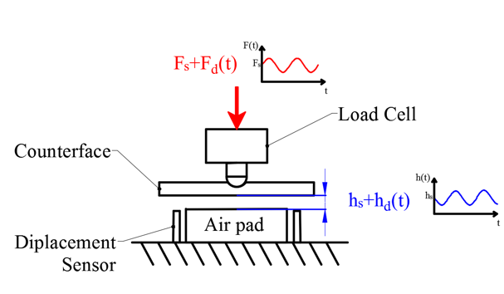  Figure 1a: Fixed pad configuration (Forced Analysis) | 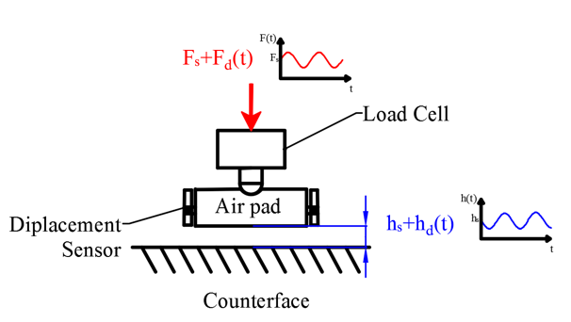  Figure 1b: Laid pad configuration (Forced Analysis)
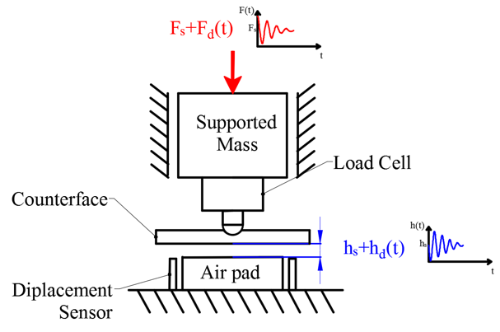  Figure 2a: Fixed pad configuration (Transient Analysis) | 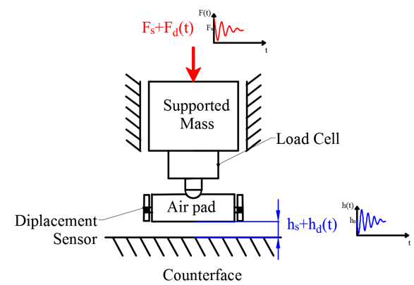  Figure2b: Laid pad configuration (Transient Analysis)
Forced response analyses employ signals which focus their energy content over a-defined frequency range in a narrowband excitation. On the opposite, transient response analyses provide excitations with an energy content that extends over a broadband frequency range. Consequently, the estimations obtained through these two types of analyses are characterised by different signal-to-noise ratios, thus leading to dynamic identifications with different qualities.
Plessers and Snoeys [23] placed the bearing on a dynamometric table and provided static and dynamic loads on it through a lever arm. An accelerometer was used in combination with displacement sensors to evaluate and compensate the inertia force of the table fixed on three load cells. After this, similar test rig architectures can be found in [28,37]. A slightly different configuration was employed by Iruikwu et. al. [38] who employed a piezo actuator as exciter and a journal air bearing to reduce the external force misalignments.
The fixed bearing configuration was adopted by Al-Bender et al.[3] to measure the dynamic stiffness of an actively controlled pad. The adopted test rig consisted in a box frame configuration where an air pot was used in combination with an electromagnetic shaker to provide static and dynamic loads respectively. Also Yoshimoto et al. [33,35,36] adopted the fixed bearing configuration.
Colombo et al. [31,34] designed and utilised a test bench to perform step force tests by adopting a laid bearing configuration. The damping and natural frequencies of the ATB were estimated by analysing the pad oscillation with the aid of the half-power-bandwidth method. Yoshimoto et al. [28,30,31] adopted the fixed bearing configuration and utilised an iterative dynamic identification procedure to understand how the bearing damping varies with the excitation frequency.
Figure 3 shows the test bench designed for this work. The laid pad configuration is adopted and a forced response analysis is performed. The air pad 1 is placed on an interchangeable base 2 whose material can be chosen depending on the requirements and goals of the test. The air gap is measured through four displacement sensors 3, which are inserted in the base. The preload is applied on the pad using a single acting cylinder 4, while the dynamic load is superposed by means of shaker 5. The upper extremity of the piston-rod is connected to the shaker by means of a stinger 6, which allows to transmit only a vertical force. A load cell 7, inserted between the pad and the cylinder, measures the total load on the pad. The regulation of the cylinder supply pressure allows the imposition of the static preload, to which corresponds a flying height for the bearing. The cylinder is endowed of two internal springs which retract the connecting rod when the supply pressure of the cylinder is cut off. The use of the cylinder, differently from external weights, introduces a negligible extra mass between the shaker and the pad and provides a force that can be precisely controlled. As known, the stinger decouples the modal exciter from the remaining parts [30,31]. The air consumption of the ATB under test is measured by a digital flowmeter located at the upstream of the pad. The signals from the load cell, the displacement sensors, the flowmeter and other additional devices, e.g., accelerometers, are sent to the acquisition system.
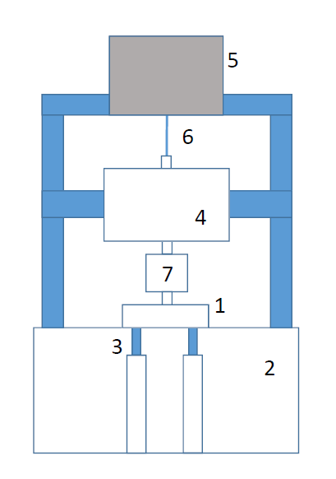
Figure 3: Scheme of the adopted test bench

Mathematical model
The pressure distribution under the pad was computed by solving the Reynolds’ equation for compressible fluids:
$$\frac{d}{dx}\left(ρ\frac{h^{3}}{μ}\frac{dp}{dx}\right)+\frac{d}{dy}\left(ρ\frac{h^{3}}{μ}\frac{dp}{dy}\right)=12 \frac{d(ρh)}{dt}$$ | (1)
where $h$ is the air gap height, $p$, $μ$ and $ρ$ are the air pressure, viscosity and density respectively. Isothermal expansion of the fluid is supposed. The equation is discretized with finite difference technique under the following boundary conditions:
- ambient pressure at the edges of the pad
- input flow through the supply holes
The theoretical flow rate $G_{th}$ of a hole is computed as:
$$G_{th}=\frac{πd_{s}^{2}}{4}\frac{0.6855}{\sqrt{RT}}p_{s}\sqrt{1-Φ^{2}}$$ | (2)
where, $d_{s}^{}$and $p_{s}$ are the holes diameter and the supply pressure respectively. Term $Φ$ [5] takes into account the pressure drop between the upstream ($p_{s}$) and downstream ($p_{c}$) pressures of the nozzles:
$$Φ=\frac{\frac{p_{c}}{p_{s}}-0.528}{1-0.528}$$ | (3)
This equation is valid for subsonic flow ($\frac{p_{c}}{p_{s}}>0.528)$. In presence of sonic flow through the nozzles, $Φ$ is null. A discharge coefficient $c_{d}$ is used to relate experimental and theoretical flow rates through
$$c_{d}=\frac{G_{in}}{G_{th}}$$ | (4)
This coefficient was experimentally determined by tests carried out on pads with different supply holes diameters and lengths [6]. The following formula was the result of this identification
$$c_{d}=0.85\left(1-e^{-8.2\frac{h}{d_{s}}}\right)\left(1-0.3e^{-0.001Re}\right)$$ | (5)
where Re is the Reynolds number related to the cross section of supply hole,
$$Re=\frac{4G}{πμd_{s}}$$ | (6)
and G is the mass air flow through each supply hole. Equation 6 considers the discharge coefficient as a function of ratio $h/d_{s}$ and gives a better approximation respect to considering a constant discharge coefficient. c_{d} is 0.85 at high values of the air gap and then decreases if h is decreased. The load capacity of the pad is obtained by integrating the gauge pressure distribution on the pad surface:
$$F=\int{\left(p-p_{a}\right) dA}$$ | (7)
The algebraic equations system is solved both in static and dynamic conditions. Stiffness $k$and damping $c$ of the bearing are computed supposing a small sinusoidal variation $∆h$ of the air gap around the static value h_{s} at a given frequency $Ω$
$$h=h_{s}+∆h\sin\left(Ωt\right)$$ | (8)
and computing the related bearing force:
$$F=F_{s}+∆F\sin\left(Ωt+φ\right)$$ | (9)
where $φ$ is the phase lag between F and h. Hence, the coefficients are computed as:
$$k=-\frac{∆F\cos{φ}}{∆h}$$ | (10)
$$c=-\frac{∆F\sin{φ}}{Ω ∆h}$$ | (11)

Experimental procedure
Three pads with the same supply holes configuration were tested both in static and dynamic conditions. Figure 4a depicts one of them and figure 4b sketches the geometry of the pads. Eight supply holes are distributed on a supply rectangle of size 55 mm x 30 mm; their diameter is 0.2 mm (pad A), 0.3 mm (pad B) and 0.4 mm (pad C), as shown in the enlargements of figure 5 obtained with an optical microscope.
These pads were tested with gauge supply pressure equal to 0.3, 0.4 and 0.5 MPa.
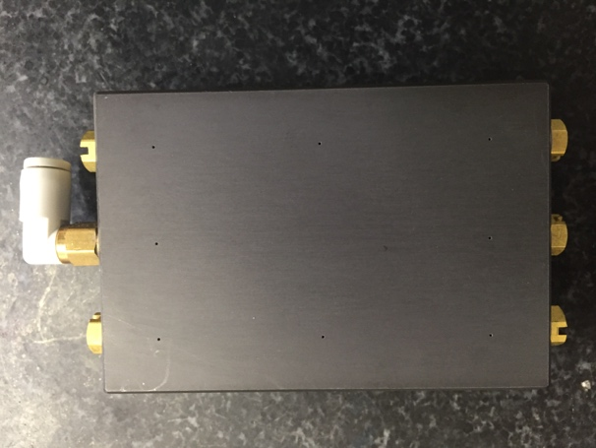
Figure 4a: Photograph of the investigated pad. |  | Figure 4b: Scheme of the pad geometry.
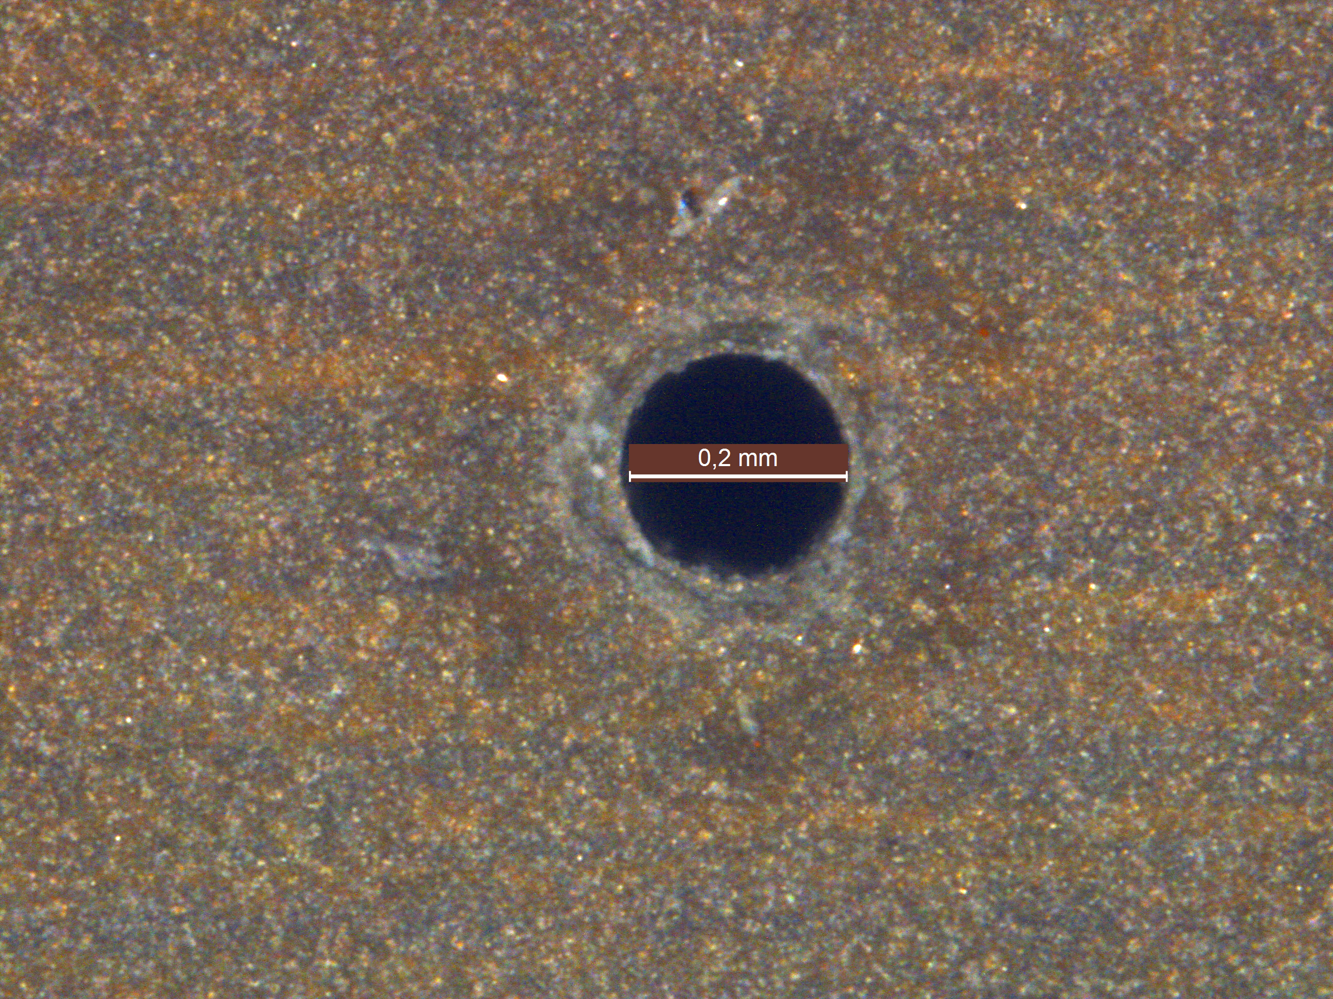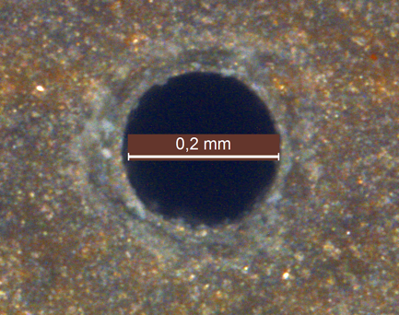 | 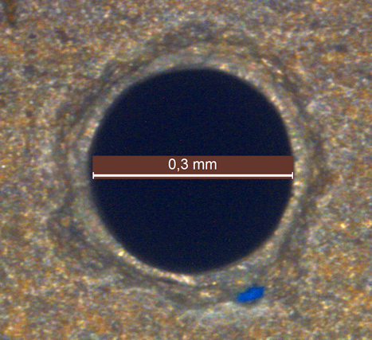 |  | 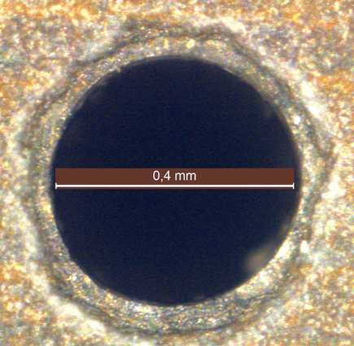
Figure 5a: Photograph of one of the inherent holes of Pad A | Figure 5b: Photograph of one of the inherent holes of Pad B |  | Figure 5c: Photograph of one of the inherent holes of Pad C

Static procedure
Load carrying capacity F, static stiffness k_{s} and air mass flow G were measured vs the air gap h under the pad. The following procedure was adopted. In point 1 the pad is loaded with no air supply; a force higher than the maximum load capacity of the pad is given. When the air supply is provided, the air flow is no more null due to small leakages (point 2). Then the external load is gradually reduced up to point 3. The air supply is then cut off to arrive in point 4. From this point, the external load is gradually increased in order to return to the initial point 1. Portion 41 of F vs h diagram indicates a small deformation of the pad as it is not exactly vertical. Portions 23 of the diagrams indicate the static curves of the pad after that it detaches from the base. The point in which the pad detaches from the base is visible in the F vs h curve when the slope begins to suddenly decrease.
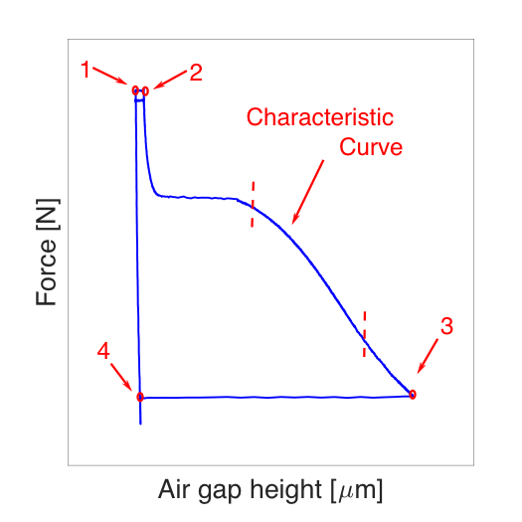 | 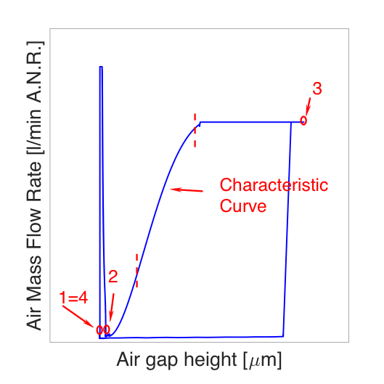
Figure 6a: Example of measurement to obtain the load capacity curve of pads. | Figure 6b: Example of measurement to obtain the air mass flow curve rate of pads.

The cycle was repeated three times for each test to check the repeatability. Four displacement sensors are used to check eventual tilting of the pad.

Dynamic procedure
A forced response analysis is carried out to experimentally evaluate the transfer function between the air gap and the load capacity. This analysis was preferred respect to the transient response analysis for two reasons: i) the possibility of evaluating stiffness and damping coefficients at different excitation frequencies and ii) the higher signal-to-noise ratio of the forced response analysis. The frequency range explored is up to 200 Hz and the air gap height is from 8 to 20 micrometers.
The test procedure is the following: initially the external load correspondent to point 2 of the static diagram is applied on the pad and the air is supplied, then the load is decreased up to reach the desired air gap. Afterwards, a dynamic force is superimposed to the static one by the electro-magnetic shaker. The amplitude of the dynamic force is selected in order to have a small perturbation of the air gap (about 0.5 μm) and at the same moment a good signal-to-noise ratio. A chirp signal is given as reference to the shaker in order to investigate all the frequency range at once. Data are collected with a sampling rate equal to 1000 Hz and the duration of the frequency sweep is 80 s. The coherence between the pad displacement and the force measured by load cell 7 (see figure) was verified to be higher than 0.99. The inertia force of the pad was verified to be negligible respect to the amplitude of the dynamic applied force in all frequency range, see figure 7. To this purpose, an accelerometer was placed on the pad. Figure 7b shows the inertia force in presence of a sinusoidal excitation of frequency 250 Hz. It is less than 2% of the applied dynamic force.
Figure 7a: Comparison between the amplitudes of the measured dynamic and the inertia forces acting on the pad. | Figure 7b: The inertia force of the pad.
The experimental transfer function
$$H\left(s\right)=-\frac{F\left(s\right)}{h\left(s\right)}=k\left(s\right)+iωc(s)$$
is evaluated with Fourier analysis and stiffness and damping coefficients are then calculated.

Discussion and results
The experimental and numerical static curves are compared in figure 9 for pad A with three different supply pressures. The effect of the supply holes diameter is visible in figure 10, where pads A, B and C are compared at gauge supply pressure equal to 0.4 MPa.
Dynamic coefficients of stiffness and damping obtained at a low frequency (20 Hz) are shown in figures 11 and 12. The experimental and numerical static stiffness are also compared with the values at 20 Hz in figure 12a. These values are obtained by derivation of the static load respect to the air gap: $k_{s}=-\frac{dF}{dh}$.
As it can be seen from figures 11a and 12a, there is good agreement between the static stiffness and the dynamic stiffness at 20 Hz. There is an optimal air gap, in correspondence of which the stiffness is maximized. The optimal air gap increases as long as the supply holes diameter is increased from 0.2 mm to 0.4 mm. Damping capacity always decreases as the air gap is increased.
Figure 9a: The effect of the supply pressure on the load capacity of Pad A. | Figure 9b: The effect of the supply pressure on the air mass flow rate of Pad A.
Figure 10a: The effect of the supply hole diameter on the load capacity of Pads A, B and C in the presence of a relative supply pressure of 0.4 MPa. | Figure 10b: The effect of the supply hole diameter on the air mass flow rate of Pads A, B and C in the presence of a relative supply pressure of 0.4 MPa.
Figure 11a: The effect of the supply pressure on the stiffness of Pad A. | Figure 11b: The effect of the supply pressure on the damping of Pad A.
Figure 12a: The effect of the supply hole diameter on the stiffness of Pad A, B and C in the presence of a relative supply pressure of 0.4 MPa. | Figure 12b: The effect of the supply hole diameter on the damping of Pad A, B and C in the presence of a relative supply pressure of 0.4 MPa.
Figure 13 shows the trends of the dynamic stiffness and damping of Pad A vs the excitation frequency at different air gap heights and with a gauge supply pressure equal to 0.4 MPa. The spikes that sometimes appear in the experimental curves vs frequency are due to resonances of the test rig. At low air gaps, stiffness slightly increases increasing the excitation frequency, but increasing the air gap this is less evident. Conversely, damping coefficient decreases increasing the excitation frequency.
Figure 13a: The dynamic stiffness of Pad A expressed as functions of the excitation frequency at different air gap heights and in the presence of a relative supply pressure of 0.4 MPa | Figure 13b: The damping of Pad A expressed as functions of the excitation frequency at different air gap heights and in the presence of a relative supply pressure of 0.4 MPa

Numerical sensitivity analysis respect to the position of the supply holes
Once the numerical model was verified with experiments, the effect of the supply holes position on the pad performance was numerically investigated in case of supply holes diameter 0.2 mm and gauge supply pressure 0.4 MPa. Different sizes of the supply holes rectangle were considered, as listed in Table 1.
Table 1: Geometries considered in the numerical evaluation of the effect of the supply holes size
Pad | Size of the supply holes rectangle
A1 | 65 mm x 40 mm
A2 | 55 mm x 30 mm
A3 | 45 mm x 20 mm
A4 | 35 mm x 10 mm

The static results for pads A1 to A4 are compared in figures 14a and 14b, while the dynamic coefficients obtained at 20 Hz are compared in figures 14c and 14d. As visible in the figures, the geometry A3 is preferable for optimum load capacity, while geometry A2 is preferable for optimum stiffness. Regarding the air consumption minimization, it is better to have the supply holes near the centre of the pad. The effect on damping coefficient is not evident.
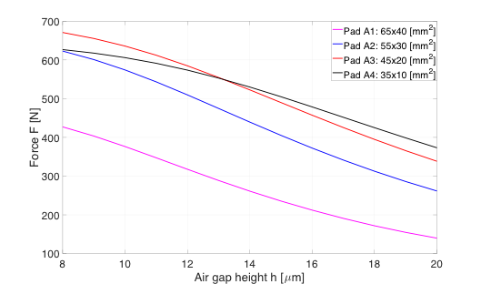 | 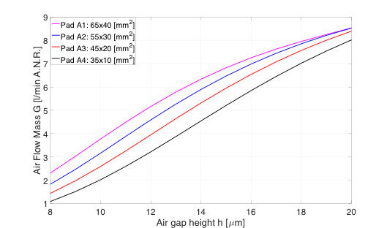
Figure 14a: The effect of the size of the supply rectangle on load capacity of Pads A1, A2, A3 and A4 in the presence of a relative supply pressure of 0.4 MPa | Figure 14b: The effect of the size of the supply rectangle on the air flow rate of Pads A1, A2, A3 and A4 in the presence of a relative supply pressure of 0.4 MPa
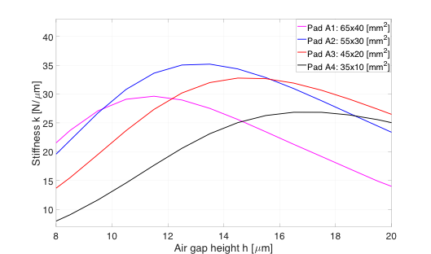 | 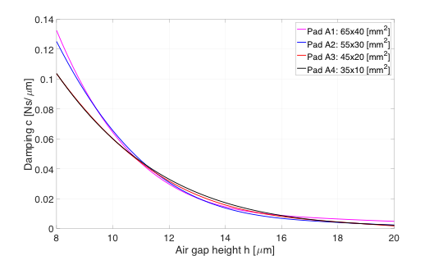
Figure 14c: The effect of the size of the supply rectangle on the stiffness of Pads A1, A2, A3 and A4 in the presence of a relative supply pressure of 0.4 MPa. | Figure 14d: The effect of the size of the supply rectangle on the damping of Pads A1, A2, A3 and A4 in the presence of a relative supply pressure of 0.4 MPa.

Conclusions
This paper describes the test rigs and the procedures adopted to characterise aerostatic pads in static and dynamic conditions. The steps needed to perform the tests are detailed. The experimental results are compared with numerical simulations in order to evaluate the numerical model, able to predict the static and the dynamic characteristics of a rectangular aerostatic bearing. The model is found to be in good accordance with the experimental results, concerning both the static and the dynamic characteristics. Once experimentally validated, the model can be used to design aerostatic pads and evaluate both their static and dynamic characteristics.
The effect of the supply holes diameter and of the supply pressure are analysed both experimentally and numerically, while the effect of the position of the supply holes is investigated only numerically. The following points can be summarised:
• The static stiffness obtained by differentiating the load capacity curve is very similar to the dynamic stiffness obtained at small frequency (20 Hz).
• Coefficient of stiffness (damping) increases (decreases) with the excitation frequency but this variation decreases increasing the air gap.
• There is an optimal air gap at which stiffness is maximum; the optimal air gap decreases when supply pressure is increased or when the supply holes diameter is decreased.
• Load capacity, air consumption and stiffness increase when the supply pressure is increased or when the supply holes diameter is decreased; the effect on damping is less relevant; the supply holes position can be chosen in order to maximise load capacity or stiffness or minimise the air consumption.
The influences of the supply pressure, the supply holes diameter and their position have been investigated. Results to other geometries can be extrapolated keeping constant the supply holes number and scaling the pad dimensions (not only the pad length and width, but also the size of the supply rectangle).

References
[1] Lentini, L., Moradi, M., and Colombo, F., (In press), “A Historical Review of Gas Lubrication: From Reynolds to Active Compensations,” Tribol. Ind, DOI: 10.24874/ti.2018.40.02.01.
[2] Raparelli, T., Viktorov, V., Colombo, F., and Lentini, L., 2016, “Aerostatic Thrust Bearings Active Compensation: Critical Review,” Precis. Eng., 44, pp. 1–12.
[3] Al-Bender, F., 2009, “On the Modelling of the Dynamic Characteristics of Aerostatic Bearing Films: From Stability Analysis to Active Compensation,” Precis. Eng., 33(2), pp. 117–126.
[4] Belforte, G., Raparelli, T., Trivella, A., Viktorov, V., and Visconte, C., 2015, “CFD Analysis of a Simple Orifice-Type Feeding System for Aerostatic Bearings,” Tribol. Lett., 58(2), p. 25.
[5] Belforte, G., Raparelli, T., Viktorov, V., and Trivella, a., 2007, “Discharge Coefficients of Orifice-Type Restrictor for Aerostatic Bearings,” Tribol. Int., 40(3), pp. 512–521.
[6] Belforte, G., Colombo, F., Raparelli, T., Trivella, A., and Viktorov, V., 2013, “Experimental Analysis of Air Pads with Micro Holes,” Tribol. Trans., 56(2), pp. 169–177.
[7] Kazimierski, Z., and Trojnarski, J., 1980, “Investigations of Externally Pressurized Gas Bearings with Different Feeding Systems,” J. Lubr. Technol., 102(1), pp. 59–64.
[8] Boffey, D. A., Duncan, A. E., and Dearden, J. K., 1981, “An Experimental Investigation of the Effect of Orifice Restrictor Size on the Stiffness of an Industrial Air Lubricated Thrust Bearing,” Tribol. Int., 14(5), pp. 287–291.
[9] Boffey, D. A., and Wilson, P. M., 1981, “An Experimental Investigation of the Pressures at the Edge of a Gas Bearing Pocket,” J. Lubr. Technol., 103(4), pp. 593–600.
[10] Chen, X.-D., and He, X.-M., 2006, “The Effect of the Recess Shape on Performance Analysis of the Gas-Lubricated Bearing in Optical Lithography,” Tribol. Int., 39(11), pp. 1336–1341.
[11] Li, Y. T., and Ding, H., 2007, “Influences of the Geometrical Parameters of Aerostatic Thrust Bearing with Pocketed Orifice -Type Restrictor on Its Performance,” Tribol. Int., 40(7), pp. 1120–1126.
[12] Talukder, H. M., and Stowell, T. B., 2003, “Pneumatic Hammer in an Externally Pressurized Orifice-Compensated Air Journal Bearing,” Tribol. Int., 36(8), pp. 585–591.
[13] Grossman, R. L., 1963, “Application of Flow and Stability Theory to the Design of Externally Pressurized Spherical Gas Bearings,” J. Basic Eng., 85(4), pp. 495–502.
[14] Colombo, F., Moradi, M., Raparelli, T., Trivella, A., and Viktorov, V., 2017, “Multiple Holes Rectangular Gas Thrust Bearing: Dynamic Stiffness Calculation with Lumped Parameters Approach,” Advances in Italian Mechanism Science, Springer, pp. 421–429.
[15] Al Bender, F, 1992, “Contributions to the Design Theory of Circular Centrally Fed Aerostatic Bearings,” Phd thesis, Katholieke Universiteit Leuven.
[16] Richardson, H. H., and Cambridge, M., 1958, “Static and Dynamic Characteristics of Compensated Gas Bearings,” Trans ASME, pp. 1503–1509.
[17] Licht, L., Fuller, D. D., and Sternlicht, B., 1958, “Self-Excited Vibrations of an Air-Lubricated Thrust Bearing,” Trans ASME, 80(2), pp. 411–414.
[18] Licht, L., and Elrod, H., 1960, “A Study of the Stability of Externally Pressurized Gas Bearings,” J. Appl. Mech., 27(2), pp. 250–258.
[19] Turnblade, R. C., 1963, “The Molecular Transit Time and Its Correlation With the Stability of Externally Pressurized Gas-Lubricated Bearings,” J. Basic Eng., 85(2), pp. 297–303.
[20] Salbu, E. O. J., 1964, “Compressible Squeeze Films and Squeeze Bearings,” J. Basic Eng., 86(2), pp. 355–364.
[21] Blondeel, E., Snoeys, R., and Devrieze, L., 1980, “Dynamic Stability of Externally Pressurized Gas Bearings,” J. Lubr. Technol., 102(4), pp. 511–519.
[22] Plessers, P., and Snoeys, R., 1988, “Dynamic Identification of Convergent Externally Pressurized Gas-Bearing Gaps,” J. Tribol., 110(2), pp. 263–270.
[23] Plessers, P., and Snoeys, R., 1988, “Dynamic Stability of Mechanical Structures Containing Externally Pressurized Gas-Lubricated Thrust Bearings,” J. Tribol., 110(2), pp. 271–278.
[24] Stiffler, A. K., 1974, “Analysis of the Stiffness and Damping of an Inherently Compensated, Multiple-Inlet, Circular Thrust Bearing,” J. Lubr. Technol., 96(3), pp. 329–336.
[25] Stiffler, A. K., and Smith, D. M., 1975, “Dynamic Characteristics of an Inherently Compensated, Square, Gas Film Bearing,” J. Lubr. Technol., 97(1), pp. 52–62.
[26] Miyatake, M., and Yoshimoto, S., 2010, “Numerical Investigation of Static and Dynamic Characteristics of Aerostatic Thrust Bearings with Small Feed Holes,” Tribol. Int., 43(8), pp. 1353–1359.
[27] Renn, J.-C., and Hsiao, C.-H., 2004, “Experimental and CFD Study on the Mass Flow-Rate Characteristic of Gas through Orifice-Type Restrictor in Aerostatic Bearings,” Tribol. Int., 37(4), pp. 309–315.
[28] Charki, A., Diop, K., Champmartin, S., and Ambari, A., 2013, “Numerical Simulation and Experimental Study of Thrust Air Bearings with Multiple Orifices,” Int. J. Mech. Sci., 72, pp. 28–38.
[29] Bhat, N., Kumar, S., Tan, W., Narasimhan, R., and Low, T. C., 2012, “Performance of Inherently Compensated Flat Pad Aerostatic Bearings Subject to Dynamic Perturbation Forces,” Precis. Eng., 36(3), pp. 399–407.
[30] Colombo, F., Lentini, L., Raparelli, T., Trivella, A., and Viktorov, V., 2017, “Dynamic Model of a Grooved Thrust Bearing: Numerical Model and Experimental Validation,” pp. 506–517.
[31] Colombo, F., Lentini, L., Raparelli, T., and Viktorov, V., 2017, “Experimental Identification of an Aerostatic Thrust Bearing,” Advances in Italian Mechanism Science, Springer, pp. 441–448.
[32] Lentini, L., 2017, “Design, Test and Identification of an Active Aerostatic Thrust Bearing with a Compliant Mechanism and Piezo Actuator,” Politecnico di Torino.
[33] Nishio, U., Somaya, K., and Yoshimoto, S., 2011, “Numerical Calculation and Experimental Verification of Static and Dynamic Characteristics of Aerostatic Thrust Bearings with Small Feedholes,” Tribol. Int., 44(12), pp. 1790–1795.
[34] Colombo, F., Lentini, L., Raparelli, T., and Viktorov, V., 2017, “Actively Compensated Aerostatic Thrust Bearing: Design, Modelling and Experimental Validation,” Meccanica, pp. 1–16.
[35] Yoshimoto, S., and Kohno, K., 2001, “Static and Dynamic Characteristics of Aerostatic Circular Porous Thrust Bearings (Effect of the Shape of the Air Supply Area),” J. Tribol., 123(3), p. 501.
[36] Yoshimoto, S., Tamura, J., and Nakamura, T., 1999, “Dynamic Tilt Characteristics of Aerostatic Rectangular Double-Pad Thrust Bearings with Compound Restrictors,” Tribol. Int., 32(12), pp. 731–738.
[37] Aguirre, G., Al-Bender, F., and Van Brussel, H., 2010, “A Multiphysics Model for Optimizing the Design of Active Aerostatic Thrust Bearings,” Precis. Eng., 34(3), pp. 507–515.
[38] Iruikwu, D., Isomaa, J.-M., Korkolainen, P., Kiviluoma, P., Kuosmanen, P., and Calonius, O., 2012, “Dynamic Loading System for Air Bearing Testing,” Proceedings of the International Conference of DAAAM Baltic “Industrial Engineering,” pp. 309–314.

It must be lower than the 10-15% of the nominal air gap and sufficiently large to provide a good signal-to-noise ratio.

