Supporting Information
TiO₂ nanotube-based smart 3D electrodes by anodic oxidation of additively manufactured Ti6Al4V structures

Andrea Lamberti^{a,b*}, Diego Manfredi^{b}, Flaviana Calignano^{b,c}, Candido Fabrizio Pirri^{a,b}
ªPolitecnico di Torino, Dipartimento di Scienza Applicata e Tecnologia (DISAT), Corso Duca Degli Abruzzi, 24, 10129 Torino, Italy
^{b}Istituto Italiano di Tecnologia, Center for Sustainable Future Technologies, Corso Trento, 21, 10129 Torino, Italy
^{c}Politecnico di Torino, Dipartimento di Ingegneria Gestionale e della Produzione (DIGEP), Corso Duca Degli Abruzzi, 24, 10129 Torino, Italy
*e-mail: andrea.lamberti@polito.it

Additional LPBF experimental details

At the beginning of the LPBF process the contour of the layer structure is exposed; then, the laser beam moves within the cross section of the part along parallel paths (hatch lines) with a constant application of energy and distance between the lines called hatching distance. A second exposure of the exterior part contour is carried out to make sure that the part edges correspond exactly to the CAD data, and that part can thus be built with the correct dimensions.

For the dimensional accuracy of the sample, another parameter, the beam offset (BO), is especially important. BO is the distance from the outer edge of the layer that is to be sintered to the middle of the laser beam. As the diameter of the melted zone is usually larger than the laser diameter, it is necessary to compensate the dimensional error and the laser beam must be shifted by half the width from the contour to the inside, to make sure that the contour of the later part will correspond exactly to the original CAD data. If the BO value is higher or less than the correct value, the particles of the irradiated region may be not melted or over-melted. In this study, experiments have been carried out to find the combination of parameters that allows construction of micrometric pillar with dimension equal to CAD model.

As can be seen in Figure S1, the pillars built on the top of the parallelepiped base have a 200 µm diameter, and the distance between the centers of two neighbor pillars is of 400 µm.

Figure S1. Image of the 3D structure designed to be produced in Ti6Al4V by LPBF.

Additional anodization experimental details and FESEM images
A one-step anodic oxidation process can lead to the synthesis of disordered TiO₂ nanowires (NWs) on the top of the TiO₂ nanotubes (see Figure S2a), also known as “nanograss” layer. The formation of NWs is due to the chemical dissolution of the tube top by means of the fluoride species. This phenomenon is detrimental for NT based electrode for electrochemical device, since NWs can hamper the infiltration of solutions (dye molecules, electrolyte, etc). In order to achieve a debris-free and well-ordered array of NTs with open top surfaces and fast growth rate some expedients have to be implemented. The morphology of the Ti foil plays a crucial role; in fact, the optimal surface should be preferably textured rather than perfectly planar and smooth.
The surface morphology is crucial particularly at the beginning of the electrochemical process, thus a pre-anodization could be beneficial leading to the formation of a sacrificial TiO₂ NTs layer (usually covered by thin or thick NWs layer). After removal of the preformed sacrificial layer, the resulting Ti surface is fully covered by holes previously occupied by the bottom side of the NTs. As a consequence, the electrochemical growth of the final NT array is faster and a more ordered distribution can be obtained due to the presence of a preformed pathway.
FESEM micrographs reported Figure S2b show the surface of the Ti foil after the growth and removal of the sacrificial NT layer. The hollow-textured Ti surface was then again anodized the second (Figure S2c) or the third (Figure S2d) time, thus obtaining the well-ordered NT array.

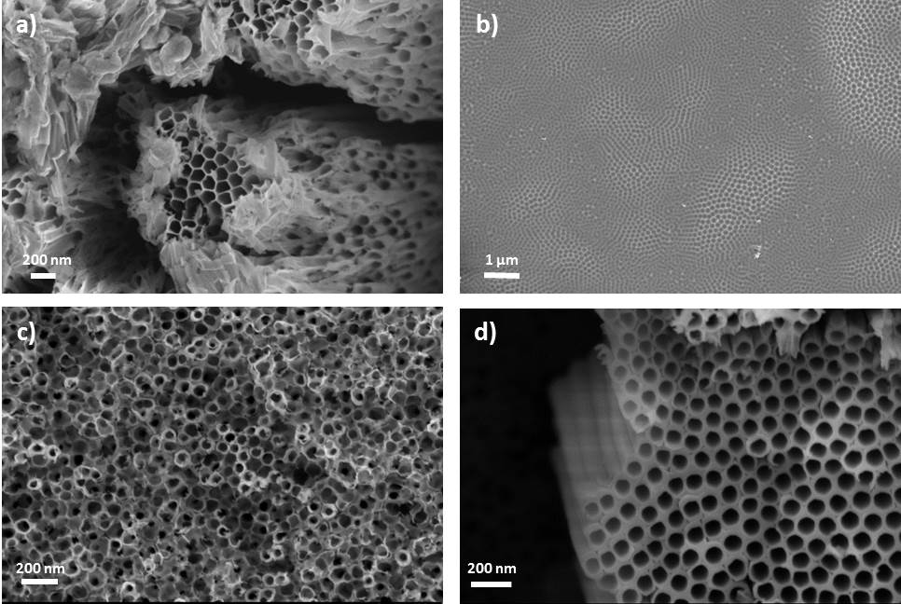
Figure S2. FESEM images showing the top view of the nanotubes after the first anodization (a), the surface of the Ti-alloy after the first NTs-detachment (b), the top view of the nanotubes after the second (c) and third (d) anodization.
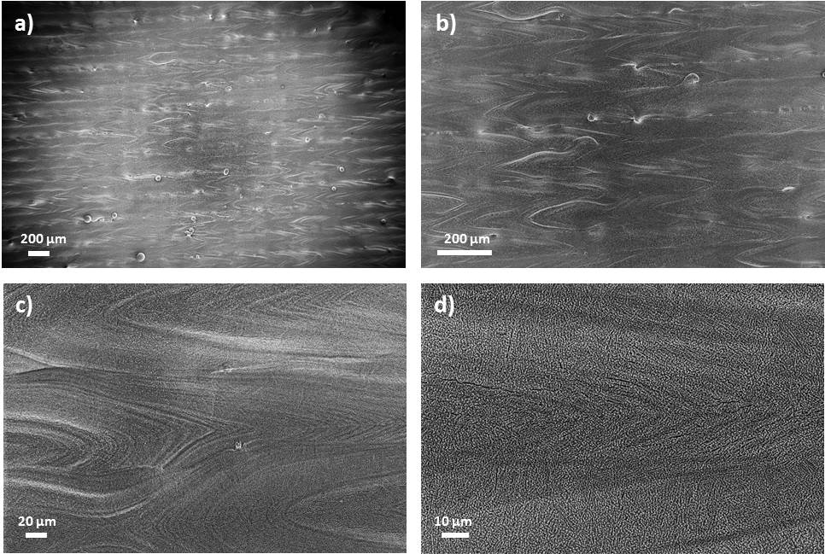
Figure S3. FESEM images showing the top view of the as-anodized 2D sample: at low magnifications (a-b) the laser scan tracks are clearly visible; at higher magnifications (c-d) it could appreciated the continuity of the TiO₂ NTs layer grown, which follows the micrometric surface morphology created by the laser beam.

