Looking inside the ‘black box’: freezing engineering for assuring quality of freeze-dried biopharmaceuticals
Luigi C. Capozzi, Andrea Arsiccio, Roberto Pisano

Department of Applied Science and Technology, Politecnico di Torino
24, corso Duca degli Abruzzi, Torino, Italy, 10129

The pharmaceutical industry is at a turning point of its history, shifting from a mass production of patented drugs to a more competitive, innovative and highly regulated market. In fact, the last few years has seen the rapid emergence of the industry of off-patented drugs and the increase of the requirements of quality, safety and efficiency set by regulatory authorities. In addition, in the next years, the production of personalized, ‘on-demand’, drugs will replace completely the old, batch, technologies with more flexible systems and continuous processes (Byrn et al. 2015). As the future of the pharmaceutical industry is continuous manufacturing, also freeze-drying of pharmaceuticals needs to be converted to continuous and integrated into the production chain.
In this perspective, the design of freezing step plays a central role to reach the more stringent requirements of quality, homogeneity and standardization of freeze-dried products (Barresi et al. 2009; Pisano et al. 2016). Both trial-and-error and black box approaches, that are widely used to design freeze-drying cycles, become not sufficient anymore. A new mindset toward research and development is required to open and look inside the ‘black box’, in order to design freezing protocols that produce dried products with the desired final attributes, to predict its variability within a production and the losses due to undesired off-target products. Of course, the product structure is a key factor in the production of stable and valuable dried products, because it affects the stability of APIs, determines the drying and desorption rate and, finally, the appearance of the product, the residual moisture and the rehydration time.
The objective of this work is to develop an innovative way for designing the freezing step in order to have a production of freeze-dried products with the desired attributes, and to have a good estimation of inter- and intra-vial heterogeneity. Our procedure consisted of coupling the distribution of nucleation temperature obtained from simple experimental tests with a detailed mathematical model of freezing. As case study, we compared the performances of two freezing protocols.
As a first step, a detailed mathematical model of freezing was developed, moving away from empirical correlation to first principles approach. This model allowed a quantitative assessment of pore structure within the vial, varying the freezing parameter, i.g., nucleation temperature and cooling rate. As shown in Figure 1a, it is possible to create a map that correlates cooling rate and nucleation temperature to the mean pore diameter in the final dried product. Since nucleation is a stochastic event, nucleation temperature cannot be analytical predicted but have to be experimentally measured.
A simple experimental campaign was carried out measuring the nucleation temperature within a statistically significant number of samples, varying the cooling rate and freezing procedure. Once the distributions of ice nucleation temperatures were collected, the mathematical model was used to correlate each nucleation temperature to the corresponded mean pore diameter in the product. In this manner, we predict the distribution of the mean pore diameter within a production of lyophilized products, and, so the inter-vial heterogeneity of the production (Figure 1b). Moreover, this approach provided a statistical description of the structure of lyophilized products within the vial and, so, a quantitative evaluation of intra-vial heterogeneity (Figure 1c).
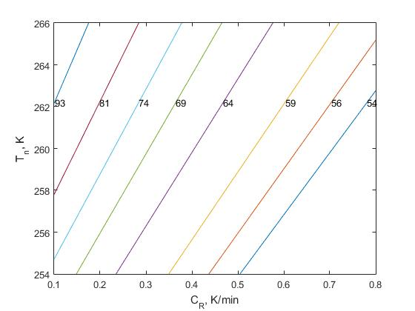 | 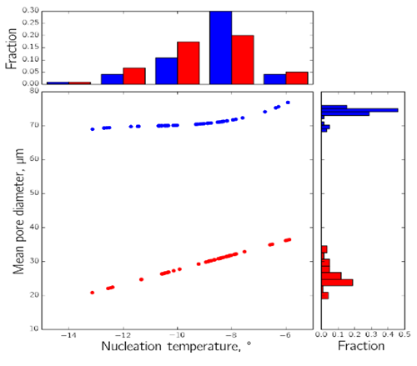
(a) | b) | c)
Figure 1 – Design of freezing step and its impact on inter- and intra-vial heterogeneity. (a) Map that correlates cooling rate and nucleation temperature to the mean pore diameter in the final dried product; (b) Inter-vial heterogeneity correlated to the distributions of ice nucleation temperatures; (c) Intra-vial heterogeneity and its variability within a production.

References
Barresi, A.A. et al., 2009. Freeze drying of pharmaceutical excipients close to collapse temperature: Influence of the process conditions on process time and product quality. Drying Technology, 27(6), pp.805–816.
Byrn, S. et al., 2015. Achieving continuous manufacturing for final dosage formation: Challenges and how to meet them. May 20–21, 2014 Continuous Manufacturing Symposium. Journal of pharmaceutical sciences, 104(3), pp.792–802.
Pisano, R. et al., 2016. Characterization of the mass transfer of lyophilized products based on X-ray micro-computed tomography images. Drying Technology, (just-accepted).

