Variable Kinematics and Component-Wise Models for Failure Analysis of Composite Structures
E. Carrera, M. Cinefra, M. Petrolo and A. Pagani

Department of Mechanics and Aerospace Engineering, Politecnico di Torino, Italy

Abstract

Composite materials present a nature more complex than classical materials. Therefore, highly accurate mechanical models are required to effectively describe the mechanics of laminated composite structures and their failure.
Many techniques are available to compute accurate stress/strain fields in the different components of a laminated structure. Many consist of using 3D solid finite elements, but the computational effort of a solid model could be prohibitive. The Component-Wise approach (see Fig.1), here proposed, separately models each typical component of a composite structures (i.e. layers, fibers and matrices) with convenient computational costs. This method is based on higher-order 1D models; moreover, different scale components can be used simultaneously, that is, homogenized laminates or laminae, modeled by 2D models (Equivalent Single Layer models (ESL) and Layer Wise models (LW)), can be interfaced with fibers and matrices. It could be seen as a “global-local” model since it can be used either to create a global model for the full laminate or a local model for those parts of the structure which could be most likely affected by failure.
The Carrera Unified Formulation (CUF) is here used to derive in a systematic way several one- and two-dimensional models with different kinematics. Classical theories, such as Classical Lamination Theory (CLT) and First-order Shear Deformation Theory (FSDT), can be obtained as particular cases. The academic software MUL2 (a finite element code based on the theories of CUF [1]) has been also interfaced with the commercial software MSC.Patran/Nastran (among the others: ABAQUS, ANSYS, etc.) in order to perform the global/local analysis of complex composite structures. This code employees 3D failure criteria for the calculation of the Failure Index (FI) in the matrix, fibers and interlaminar zones of composite structures.

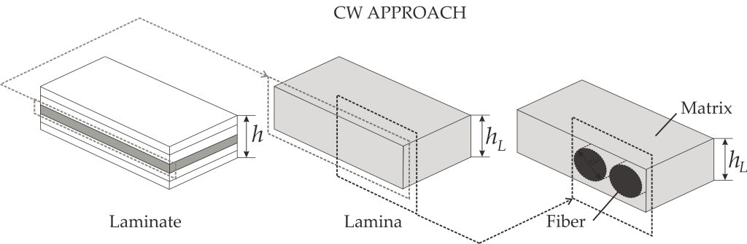

Figure 1: Component-Wise method description

[1] Carrera E., Cinefra M., Petrolo M., Zappino E., Finite Element Analysis of Structures through the Carrera Unified Formulation, John Wiley & Sons, UK, 2014.

