EXPERIMENTAL STUDY OF AIR-WATER TWO-PHASE FLOW
IN PARALLEL HELICALLY COILED PIPES

Mario De Salve, Matteo Giacomo Giraudo, Bruno Panella

Politecnico di Torino, Energy Department
C.so Duca degli Abruzzi 24, 10129 Torino, IT

ABSTRACT
The air-water two-phase flow in a 12 mm inner diameter parallel helically coiled pipes is investigated with three different coils diameters. Void fraction, flow rate distribution and two-phase pressure drops along the pipes in the parallel channels are measured. The test two-phase pressure drops are compared with theoretical ones, in terms of multipliers and friction factors. The instabilities arisen during the experimental tests are investigated and are related to the void fraction and flow quality. The void fraction values corresponding to the onset of oscillations are compared with Relap5 code results at the same fluid dynamic conditions.

INTRODUCTION
The two-phase flow investigation in helically coiled pipes is important to improve the performance of new types of steam generators, regarding heat transfer and thermal mechanical stresses and therefore experimental data can help to obtain a better design and to validate theoretical models. Some authors have carried out experiments on the fluid-dynamics in helically coiled pipes: Xin et al.[1] used an air- water mixture; Santini et al. [2],[3] investigated the transition between laminar and turbulent flow by means of water and vapour; Papini et. al.[4] performed a study about the fluid dynamic instabilities in helically coiled pipes. In this work, an experimental investigation about single-phase and two-phase flow in three parallel helically coiled pipes is presented by using an air-water mixture at different flow qualities for every pipes. The flow distributions, void fraction and pressure drops are measured at each total mass flow rate and the onset of instabilities is evaluated as well.

EXPERIMENTAL FACILITY
An open tank is connected to three parallel helically coiled pipes by means of two headers. Water is driven by a centrifugal pump through an horizontal pipe to the single phase cylindrical header, that is connected to 4 branches; the first one is linked directly with the water tank, whereas the others are disposed in symmetrical way with an angle of 120°. These three branches are horizontal and constitute the inlet of the three vertical parallel helically coiled channels, that have different geometrical parameters in order to simulate the behaviour of a real steam generator with different length, pitch and turns. The three horizontal branches are all equipped with a flow meter. The two-phase flow is provided by a mixer device that is located at the inlet of each helical pipe. The facility scheme is shown in figure 1 and the instrumentation is reported in table 1. The main geometrical parameters are reported in table 2. Straight pipes of 8 mm inner diameter are located between the outlet of the coils and the inlet of the two phase flow header.
The instruments are differential pressure transducers in the range of 0-130 kPa and with 0.1% of full scale accuracy, absolute pressure transducers in the range 0-0.7 MPa and with 0.1% of full scale accuracy an orifice flow meter for the liquid flow rate with 2.5% of full scale accuracy and rotameters for the air flow rate with accuracy of 5% full scale. The total liquid flow rate is measured by a rotameter in the range (0.44 – 4.4) kg/s with 1% of full scale accuracy.

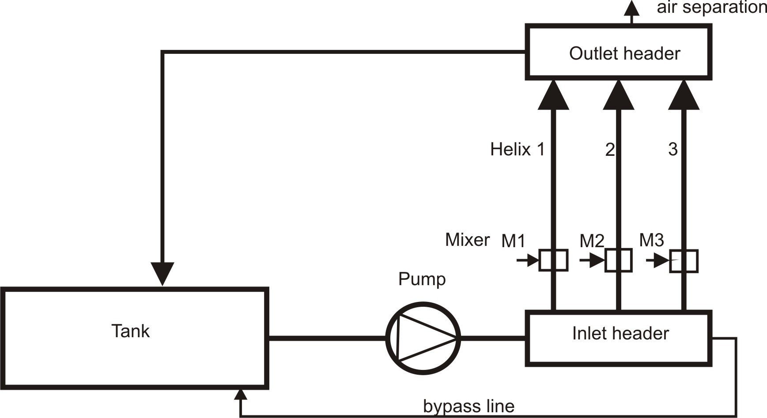
Figure 1: Facility scheme

Table 1: Instrumentation
Instruments | Serial n° | Range
Pressure transducer | AAH1535F | 0-130 kPa
Pressure transducer | ABF0872F | 0-130 kPa
Pressure transducer | AAH1526F | 0-130 kPa
Pressure transducer | 8502348 | 0-7 bar
Pressure transducer | 9212819 | 0-2000 mmH2O
Pressure transducer | 8262614 | ± 623 mbar
Flow rate meter | COH000375 | 1600-16000 l/h
Flow rate meter | COF002068 | 0.077-0.77 nm3/h
Flow rate meter | COF002068 | 0.31-3.1 nm3/h
Pressure transducer | 92128180 | 0-15 bar
Pressure transducer | 255 | 0-5 psi
Pressure transducer | 515 | 0-7.2 psi
Pressure transducer | 308 | 0-10 psi
Pressure transducer | 1277 | 0-7.2 psi
Pressure transducer | 932 | 0-14.4 psi
Pressure transducer | 1175 | 0-14.4 psi
Pressure transducer | 517 | 0-30 psi
Table 2: Geometrical parameters
Helical coils number | 1 | 2 | 3
Coil diameter: D[m] | 1.39 | 1.0 | 0.64
Pipes inner diameter: d_{i} [mm] | 12 | 12 | 12
Branch lengths [m] | 1.2 | 1.2 | 1.2
Helical pitch: p[m] | 0.954 | 0.80 | 0.485
Helical height: H[m] | 2.862 | 2.4 | 2.4
Helical Length: L[m] | 13.9 | 10.0 | 10.85
Turns | 3 | 3 | 5
Outlet straight pipe length [m] | 5.52 | 0.71 | 2.82

single phase flow experimental results
The first tests have been carried out in single-phase flow; this approach is necessary to calibrate the instrumentation and to evaluate the flow rate distribution and pressure drops both in the horizontal channels and in the helically coiled pipes.
These tests are performed by varying the total flow rate in the three parallel channels in order to get several flow conditions in the range of total flow rate between 0.45 kg/s and 0.6 kg/s; the ratio between the flow rate in a single channel and the total flow rate is kept constant for each channel (table 3).

Table 3: Flow rate ratio
Channel | 1 | 2 | 3
Flow rate ratio | 0.25 | 0.45 | 0.30
Loop total length [m] | 20.6 | 11.9 | 14.85

The flow rate ratio is lower as the length increases, due to the hydraulic resistance which increases with the length. The hydraulic resistance depends on several geometrical parameters like diameter, length, roughness and the total length.

The loop pressure drops is expressed by equation 1:

(1)

The pressure drops are measured both in the horizontal branches (fig. 2) and in the helically coiled pipes (fig. 3).
The pressure drops increase with the mass flux following a power law with an exponent of about 1.64 in the horizontal branchs. This exponent can be explained by considering that the friction factor in case of turbulent flow depends on , which leads to a pressure drop dependence as expressed in equation 2.

(2)

The value of the m coefficient depends on the correlation that is chosen for the friction factor; if the Ito and Blasius correlations are adopted, m is 0.25.
Figure 3 shows the pressure drops in the helically coiled pipes as a function of the mass flux: several measurements that are obtained in the same loop are presented in order to check the repeatability of the results. The difference ξ=2-m is a function of the friction factor and in the case of helical pipes is about 0.5 (fig. 4).
Looking at the results shown in the figure 3, the pressure drops values in the second and third helically coiled pipes are consistent with the ones obtained by Bertani et al.[5] while the pressure drops measured in the first helical channel seems to be a little underestimated. However, even in this case, it is clear a parabolic behavior of the pressure drops in agreement with the correlations.
In order to compare the single-phase flow experimental results with the correlations, the Reynolds numbers from the test data are used to calculate the Fanning friction factors and then the pressure drops by means of the correlations.
The Reynolds number is evaluated from the flow rate measured in the channels (equation 3).

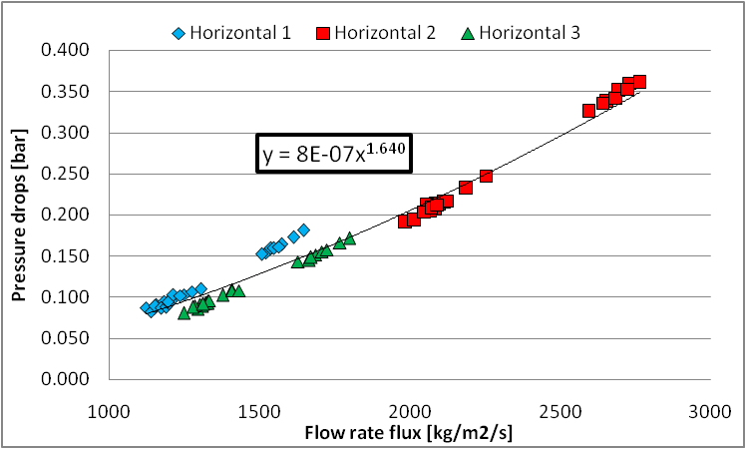
Figure 2: Pressure drops in the horizontal branches

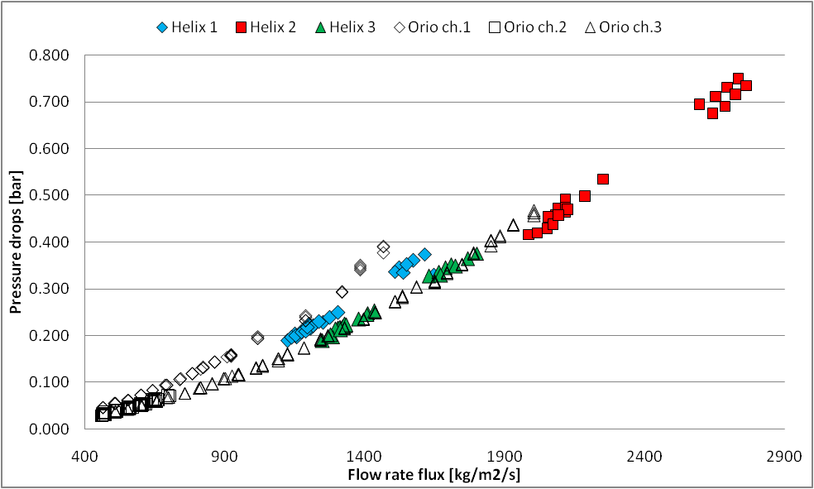
Figure 3: Pressure drops in the helically coiled pipes

(3)

The Fanning friction factor is evaluated by means of the Blasius and Ito correlations for turbulent flows, as reported in equations 4 and 5.

(4)

(5)

with: 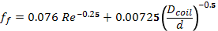

The friction factor is used to evaluate the pressure drop through the equation 6.

(6)

As shown in figure 4, some experimental data are less the Blasius data of a straight pipe. This results agree with the finding of Santini et al.[3] which introduce a depression zone where the pressure drops in helical pipe are less of the pressure drop in the straight pipe for the same flow rate.

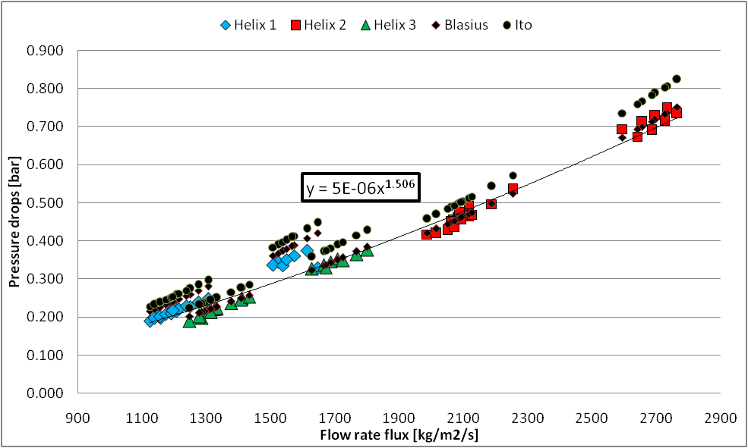
Figure 4: Helical coils pressure drops compared with Blasius and Ito correlations.

two-phase flow RESULTS

Experimental Procedure
The experimental procedure consists in establishing the two-phase flow only in one channel, while the two others are in single phase flow condition, in order to simplify the operations; so compressed air is injected in a single channel through the mixer and, as a consequence, the water flow rate splits in the three channels to get the same pressure drops in all the parallel channels. The test runs are carried out by varying the flow rate in each channel; the range of Dean number in the different tests is shown in table 4.

Table 4: Dean number in test data.
Dean number | Channel 1 | Channel 2 | Channel 3
MIN | 318.3 | 1038.1 | 506.7
MAX | 741.3 | 2265.6 | 1400.4

The liquid flow rate ratios with respect to the total liquid flow rate versus the superficial air velocity of the two phase flow channel , are presented in figure 5: the channel 2 has a different behaviour with respect to the others because, for two-phase flow, the water flow rate in that channel is larger than in the others.

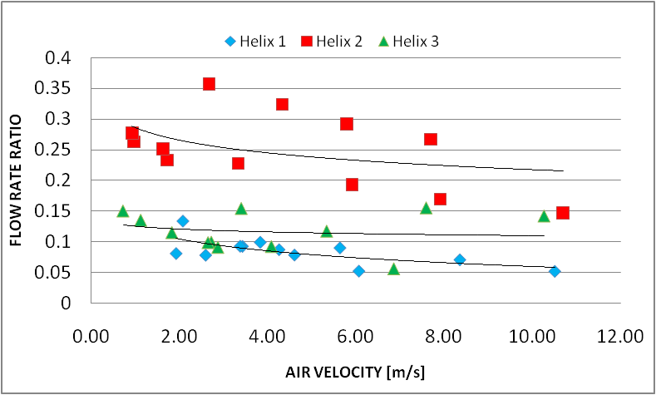
Figure 5: Water flow rate ratio between single channel and total flow rate

Void fraction measurements
In the tested flow quality range (up to 0.08) typical slug and churn flow patterns have been observed. The void fraction is evaluated by means of the "weight method", by comparing the amount of water either for single-phase flow or for two-phase flow inside the helically coiled pipes. The void fraction as a function of the flow quality is reported in figure 6: at low quality values the increase of the void fraction is quite large due to the slug flow pattern occurrence, whereas at larger quality values the void fraction becomes more stable in correspondence of an annular flow pattern.

Pressure drops measurements
The two-phase flow pressure drops values measured in the helically coiled pipes are used to get the two-phase multipliers: the test data are compared with the Xin [6] correlation that takes into account also the effects due to the curvature of the pipes (equations 7 and 8, where Fr is the Froude number as reported in equation 9).

(7)

(8)
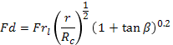
(9)

The Froude number for the experimental data varies from a minimum value for the first channel up to 25.6 for the second one. The comparison between the experimental multiplier and that predicted by the Xin correlation is shown in figure 7.

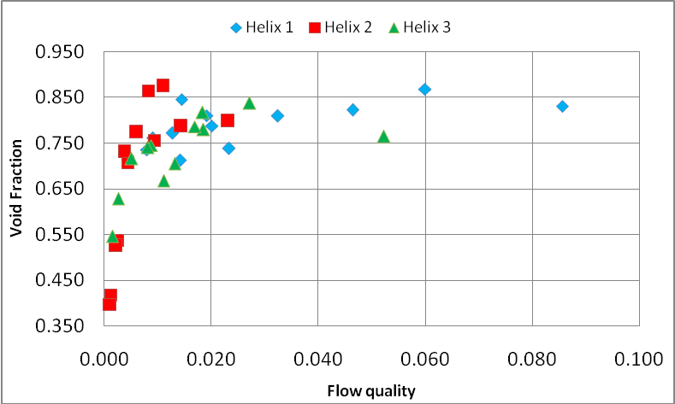
Figure 6: Void fraction against flow quality.

The results show that the Xin model correlates the two phase multiplier experimental values within 40% at a probability level of 75 %.
Another comparison is performed between the measured pressure drop and the one predicted by Shannak [7], who evaluated from the Reynolds number (eq. 10) the two-phase friction factor (eq. 11) which determines directly the two-phase pressure drop. The comparison is shown in figure 8.

(10)
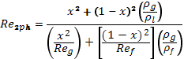
(11)
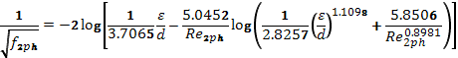
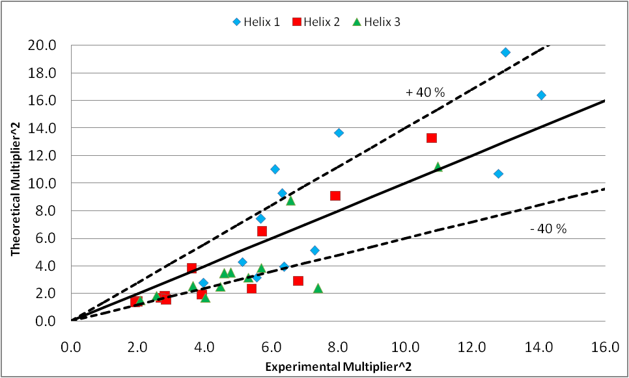
Figure 7: Comparison between the experimental and predicted by Xin multiplier.

The results show that the Shannak model correlates the two phase pressure drop experimental values within 50% at a probability level of 79 %. Helix 3 seems to behave in a different way if compared to the other helically coiled pipes; it is likely due the lack of dependence on the helical diameter in the Shannak formulation [7], leading to a poor agreement with the experimental results.

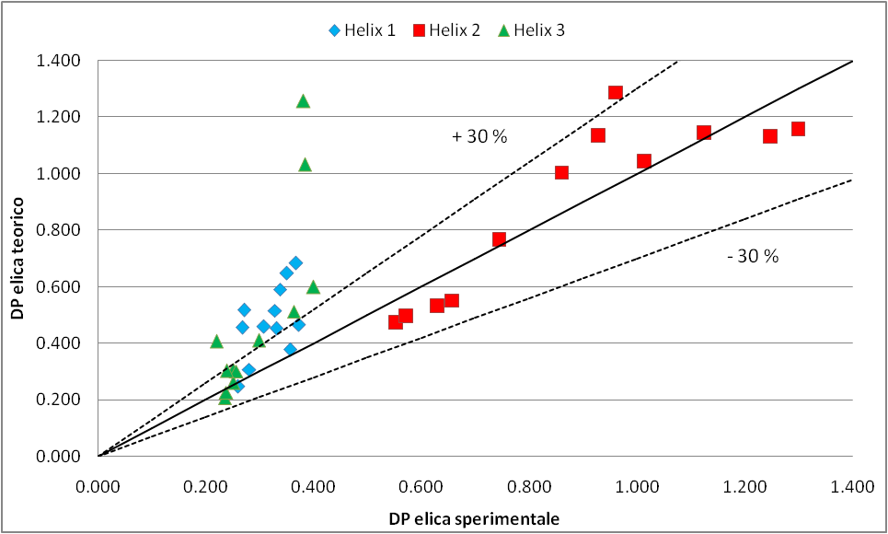
Figure 8: Comparison between the experimental and predicted by Shannak pressure drops.

Fluid Dynamic instability

Measurements
Some tests have experienced the arising of flow rate oscillations in the helical test section with two-phase flow and, as a consequence, also in the other two helical pipes. Frequency, void fraction and flow quality when the oscillations occur are reported in table 5.
In correspondence of the onset of the instability, the void fraction and the flow quality are evaluated; the aim is to identify some critical or limit conditions for which oscillations arise.
Looking at the experimental data, a boundary zone is identified at void fraction ranging from 0.7 to 0.8. At void fraction values lower than 0.7 there are no oscillations, whereas for values higher than 0.8 all the tests experience a certain flow rate oscillation. This behaviour suggests that the oscillations are due to the "flow pattern instability" because they are clearly related to the flow pattern transition. More in detail, in case of oscillations, the flow pattern is a fully developed slug flow type, as shown in figure 9.

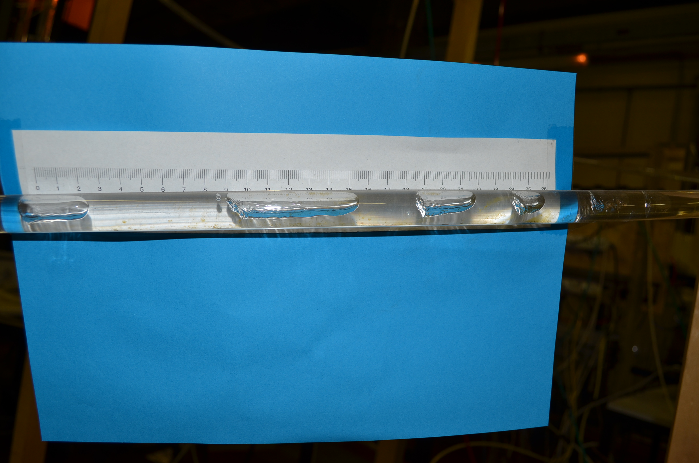
Figure 9: Slug flow picture.
Table 5: Onset of oscillation
Channel flow rate [kg/s] | Frequency [Hz] | Void fraction | Flow quality
0.049 | 0.112 | 0.772 | 0.013
0.045 | 0.133 | 0.846 | 0.014
0.042 | 0.153 | 0.810 | 0.019
0.026 | 0.071 | 0.821 | 0.046
0.037 | 0.143 | 0.738 | 0.023
0.047 | 0.122 | 0.711 | 0.014
0.020 | 0.051 | 0.830 | 0.086
0.050 | 0.184 | 0.704 | 0.019
0.030 | 0.112 | 0.779 | 0.052
0.042 | 0.163 | 0.809 | 0.032
0.033 | 0.092 | 0.868 | 0.060
0.153 | 0.031 | 0.864 | 0.010
0.137 | 0.143 | 0.875 | 0.015
0.063 | 0.245 | 0.816 | 0.018
0.061 | 0.255 | 0.837 | 0.027

Comparison with Relap5/Mod3.3 code
The void fraction values that are measured in correspondence to the onset of instability are compared with the values predicted by RELAP5/MOD3.3 code[8]. The aim is to understand if the code is able and reliable to predict the instability, even if one-dimensional. For this analysis the facility has been simulated with three parallel channels that are inclined to simulate the difference between the three helically coiled pipes, but, of course, because of the one-dimensional structure of the code, the effects due to the curvature and the secondary flows have been neglected.
The comparison between the void fraction predicted results and the experimental ones is shown in figure 10: the results show that the all the points are correlated within 20 % .

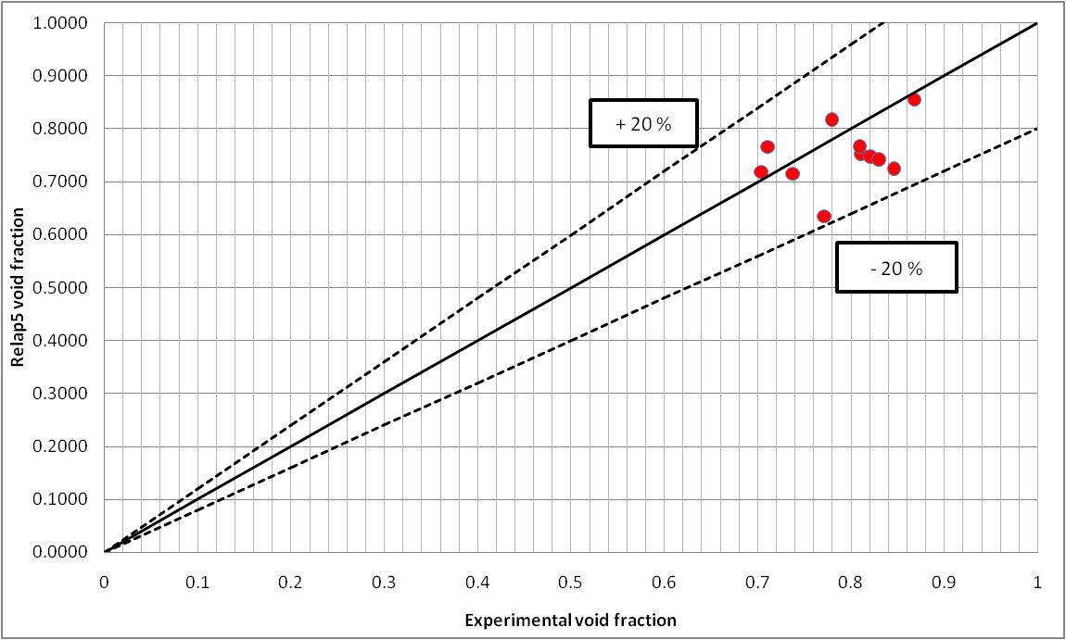
Figure 10: Comparison between experimental and predicted by RELAP5/MOD3.3 void fraction values.

CONCLUSIONS
An experimental campaign has been carried out to study the fluid-dynamics in parallel helically coiled pipes. The comparison between the Xin model and the two phase multiplier experimental values shows that it correlates the data within 40% at a probability level of 75 %. As regards the comparison between the Shannak correlation and the second helical two phase pressure drops test data, the Shannak model correlates the two phase pressure drop experimental data within 50% at a probability level of 79 %.
The experimental tests have highlighted the importance of the instability phenomena for certain conditions at high void fraction (table 5); in particular, in case of a non-heated pipe, the flow pattern instability determines very strong flow rate oscillations with an amplitude up to ± 100% of the average flow rate. The flow pattern instability in a single two-phase channel determines the flow rate oscillations also in the other single-phase channels (parallel channel instability).
Finally, the comparison of the test data with the results of RELAP5/MOD3.3 code shows that, even if the code is an one-dimensional code, the prediction of the onset of the flow pattern instability is rather good with all the void fraction test values correlated within 20 %.

Acknowledgement
This research has been financially supported by ENEA. The authors wish to thank R. Costantino and G. Vannelli for their technical support.

NOMENCLATURE
W_{i} | Channel flow rate | kg/s
W_{tot} | Total flow rate | kg/s
L | Loop length | m
D | Coil diameter | m
d_{i} | Inner diameter | mm
d_{e} | Outer diameter | mm
p | Helical pitch | m
H | Coil height | m
 | Reynolds number
 | Dean number
 | Froude number
β | Coil angle
V_{l} | Liq. Superficial Velocity | m/s

REFERENCES
[1] R.C. Xin, A. Awwad, Z.F. Dong, A. Ebadian, An investigation and comparative study of the pressure drop
in air-water two-phase flow in vertical helicoidal pipes, International J. Heat Mass Transfer, vol. 39, Issue 4, pp. 735-743,1996.
[2] L. Santini, A. Cioncolini, C. Lombardi, M. Ricotti, Two-phase pressure drops in a helically coiled steam generator, International J. Heat Mass Transfer, Vol. 51, Issue 5, pp. 4926-4939, 2008.
[3] L. Santini, A. Cioncolini, An experimental investigation regarding the laminar to turbulent flow transition in helically coiled pipes, Experimental Thermal and Fluid Science, vol. 39, pp. 735-743, 2005.
[4.] D. Papini, M.E. Ricotti, Prove sperimentali per canali in parallelo e relative zone di instabilità, Cerse-Polimi-1134, 2010.
[5] C. Bertani, M. De Salve, M. Malandrone, M. Orio, B. Panella, Fluidodinamica bifase in condotti elicoidali: influenza della geometria e delle portate, Procs. XXVII Congresso Nazionale UIT sulla Trasmissione del Calore, Reggio Emilia, 22-24 Giugno 2009, pp. 103-112, 2009.
[6] R.C. Xin, A. Awwad, Z.F. Dong, A. Ebadian, An experimental study of single phase and two-phase flow pressure drop in annular helicoidal pipes, Int. J. Heat and Fluid Flow, vol. 18, Issue 5, pp. 482-488,1997.
[7] A. Shannak, Frictional pressure drop of gas liquid two-phase flow in pipes, Nuclear Engineering and Design, Vol. 238, Issue 12, pp. 3277-3284, 2008.
[8] U.S. NRC Nuclear Safety Analysis Division, RELAP5/MOD3.3 Code Manual, NUREG/CR-5535/ Rev1 2001.

